Parent information on bar modelling
https://www.youtube.com/watch?v=I6Ipio8JntU
https://www.youtube.com/watch?v=PEAoJUYELtk
https://www.youtube.com/watch?v=i7LAHc1qvig

Before you begin, practise your times tables using Time Table Rockstars for 20 minutes

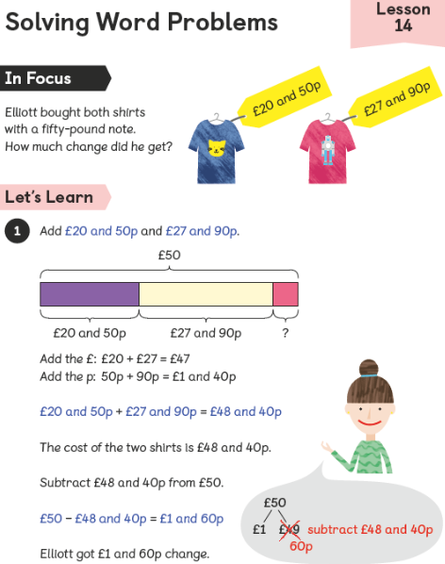
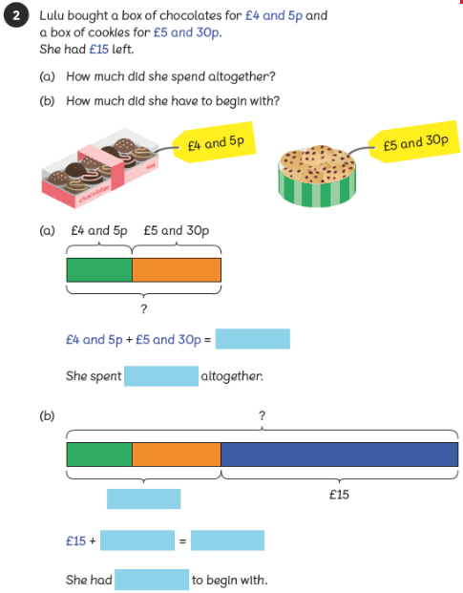

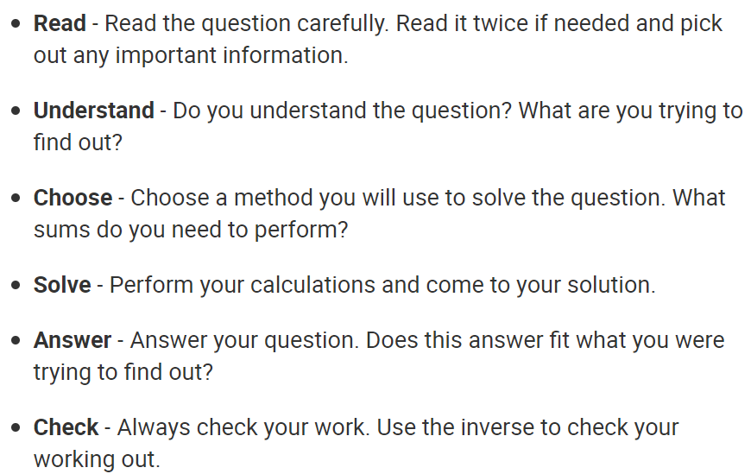

Your activity -
Write your answers below

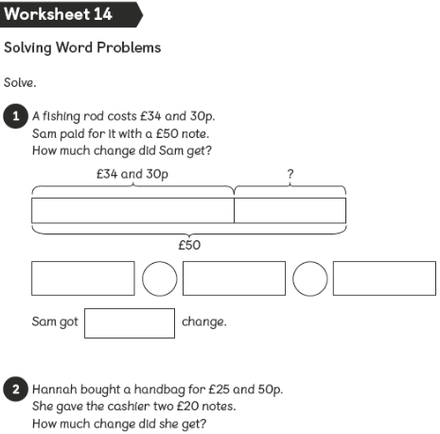
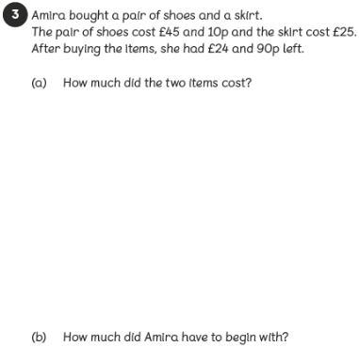

Extension
Explain how you solved your answer

Answers
1)

2)

3a)

b)

Extension

