Week 2 Ch 2 and 3 day 3
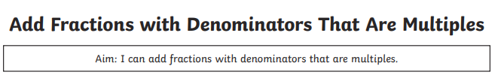
Example: ½ + ¼ + ⅛
Step one change all to the same denominator: 4/8 + 2/8 + ⅛ = ⅞
