Ch2 and 3 day 2
To find 10% of a number, you divide the number by 10.
To find 40% of a number you divide the number by 10 and then multiply it by the first digit of the % (4)
Examples: 70% of 70 = 49. 10% of 30 = 3Ch
70 / 10 = 7 30 / 10 = 3
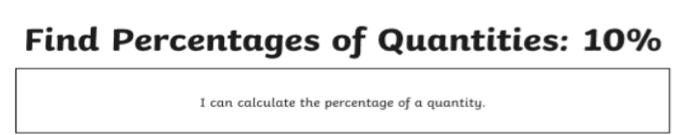
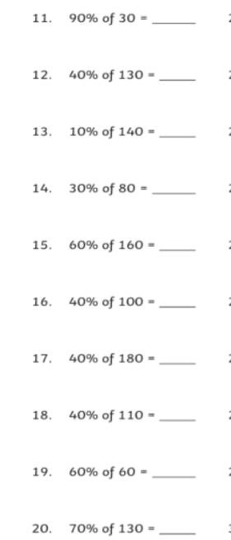
7 x 7 = 49

