Challenge 1 week 1 Topic
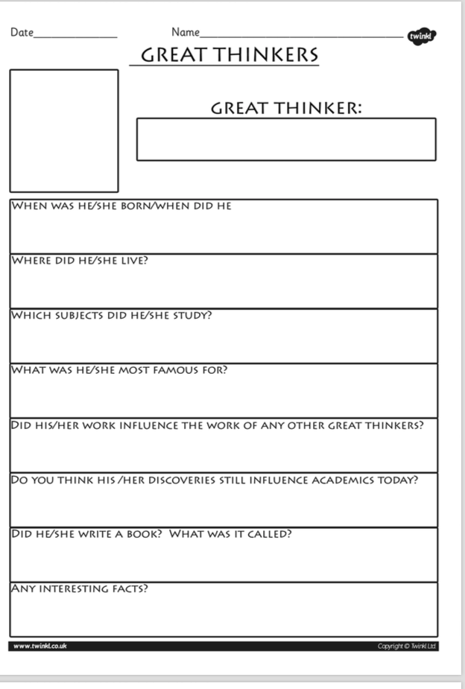

Task: Choose a ‘Great Thinker” from the ‘Islamic Golden Age’ and write about them. See the Powerpoint to find out what “Islamic Golden Age’ was and use following websites to help you.
https://www.famousscientists.org/avicenna/

https://kids.kiddle.co/Alhazen

https://www.theschoolrun.com/homework-help/baghdad-c900

