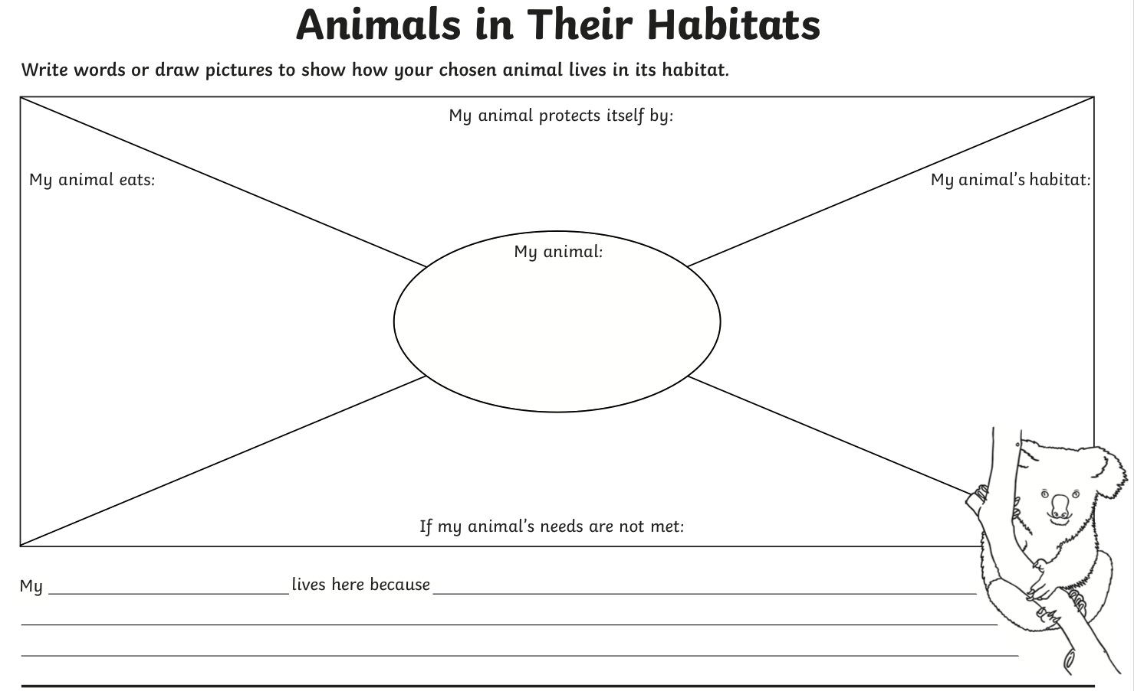

Task: Research an animal of your choice and produce a fact file. Remember to see the powerpoint to help.

