Challenge 2 week 1 Topic
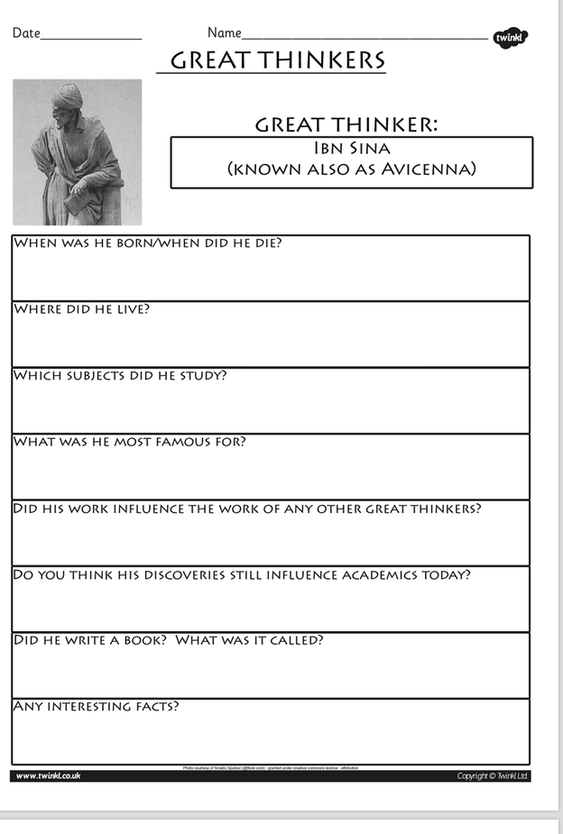
Task: Do some research on the life of Ibn Sina. Answer the above questions. See the Powerpoint to find out about the ‘Golden Age’ and use the following website to help you.
https://www.famousscientists.org/avicenna/

