Challenge 3 week 1 Topic
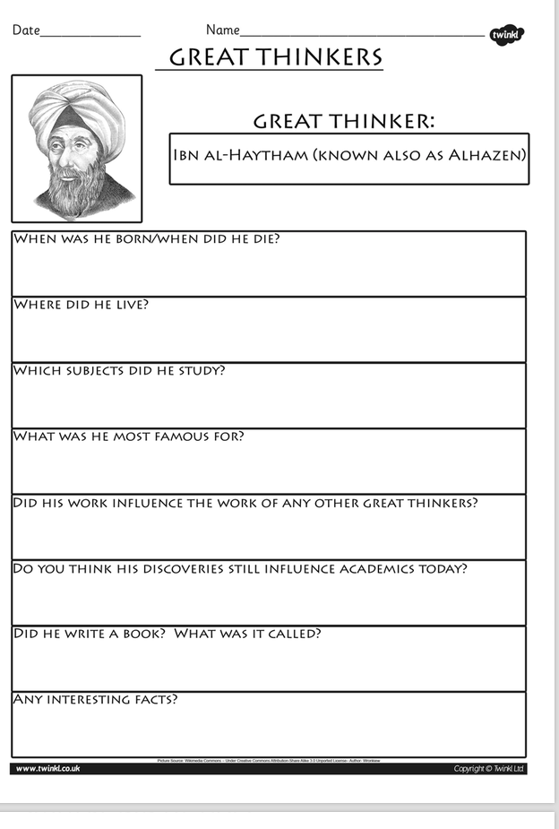

Task: Do some research on the life of Ibn Al-Haytham. Answer the above questions. See the Powerpoint to find out about the ‘Golden Age’ and use the following websites to help you.

https://kids.kiddle.co/Alhazen

https://www.theschoolrun.com/homework-help/baghdad-c900

