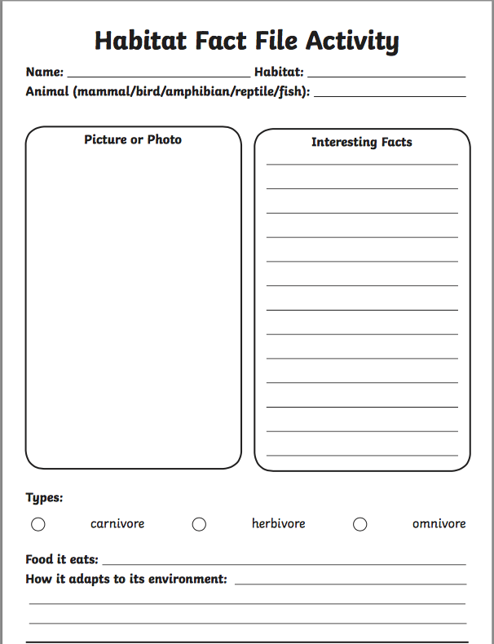

Task: Research an animal of your choice and produce a fact file.

