Skara Brae - Session 4 (History)
L.O: To understand changes in Britain during the Neolithic period.
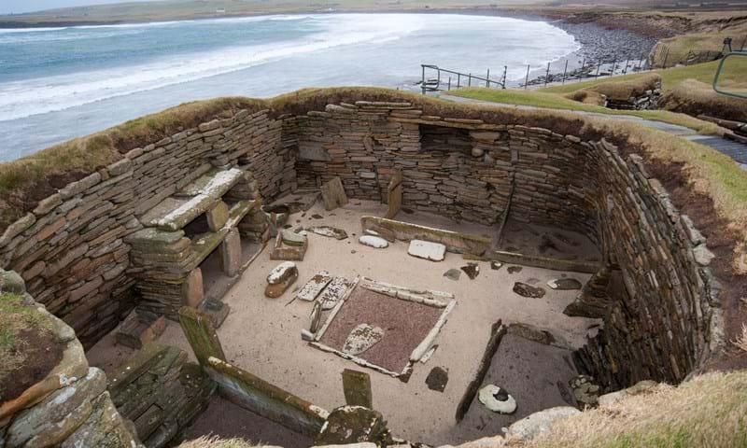

Your task is to research Skara Brae to understand life was like during the Neolithic period in Britain. Use the questions below to help you with your research. Answer each question in full sentences.

1. Where is Skara Brae located?
2. What does Neolithic mean and how is it linked to the Stone Age?
3. When was Skara Brae first discovered and by who?
4. Explain what an Archaeologist is.
4. How did people live in Skara Brae? Think about food, shelter and clothing.
5. Why is Skara Brae important today?
6. Why were the doors very short and how did they protect people?
7. Any interesting facts you can find on Skara Brae.

