LO: To plan a story

Using the pictures from our class picture book, ‘The Journey’ we would like you to create your own plan by writing bullet points below each picture.

Beginning

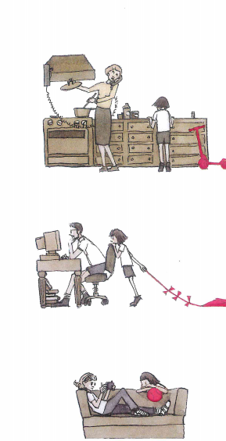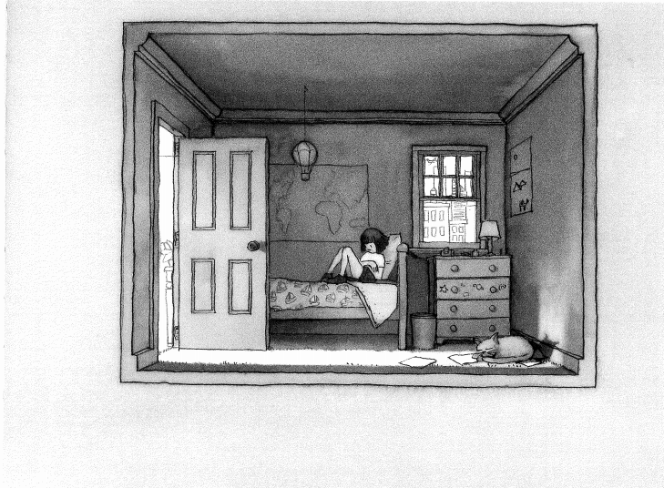

Middle
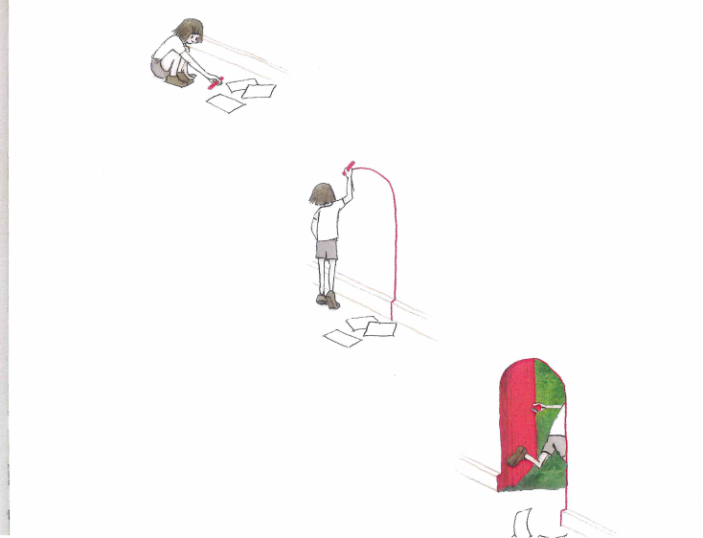

Ending
