Time

1 Circle the time that is 30 minutes before midnight.

12:30 am 12:30 pm 11:30 am 11:30 pm 3 am
1 mark
1.9a

2 Put these times in order, starting with the shortest.

5 minutes 20 seconds 1 minute 100 seconds

shortest
1 mark
1.8a

3 Here are two clock faces.
Join each clock face to the correct digital time.

2 marks
3.8b

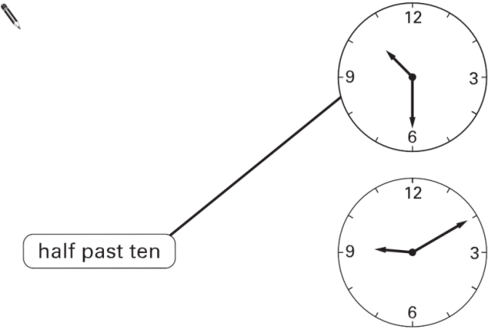
4 Match each clock to the correct time.

One has been done for you.

1 mark
3.4b

5 Here is a clock.

How many minutes is it until this clock shows 7:30?

minutes

Here is another clock.

What time will the clock show in 20 minutes?

2 marks
3.3b

6 This table shows the increase in bus fares.

Sohan’s new bus fare is 72p.
How much has his bus fare gone up?

p

Millie says,
‘My bus fare has gone up by 10p’.
How much is Millie’s new bus fare?

2 marks
3.1a

7 These are the times letters are collected from a post box.
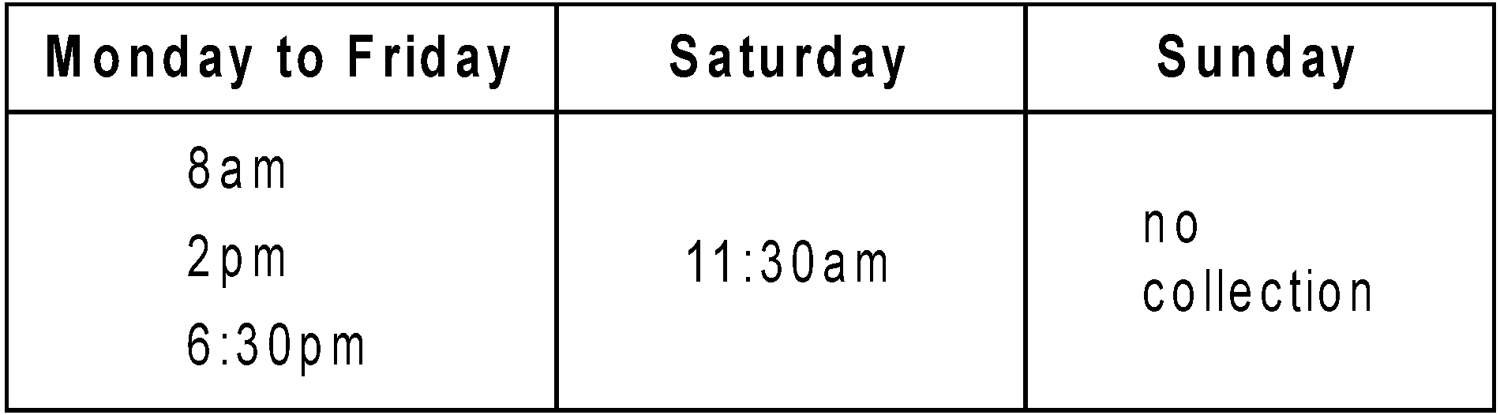
What is the latest time letters are collected on Wednesday?

Carla posts a letter at 9 am on Monday.

How long will it be before it is collected? hours

Gareth posts a letter on Saturday at 3pm.
When is it collected from the post box?

day ............................................. time .............................................
3 marks
3.99b

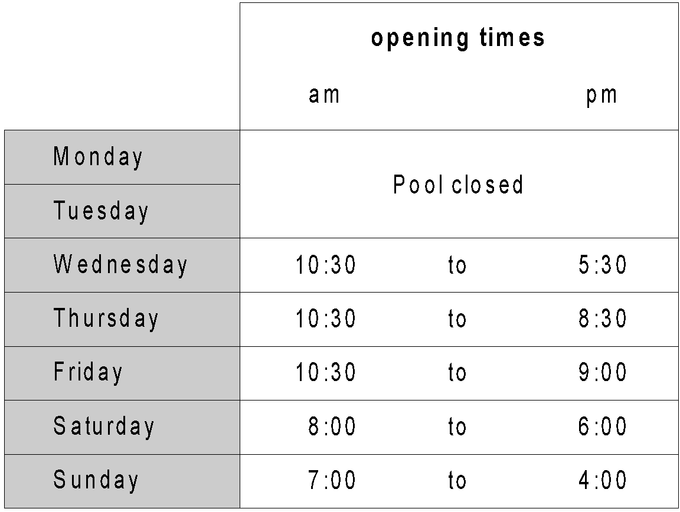
8 These are the opening times at a swimming pool.
How many hours is the pool open on a Sunday?

hours

Which day has the latest closing time?

Habib arrives at the pool at 5:20pm on Saturday.
How many minutes is it before the pool closes?

minutes
3 marks
8.0b

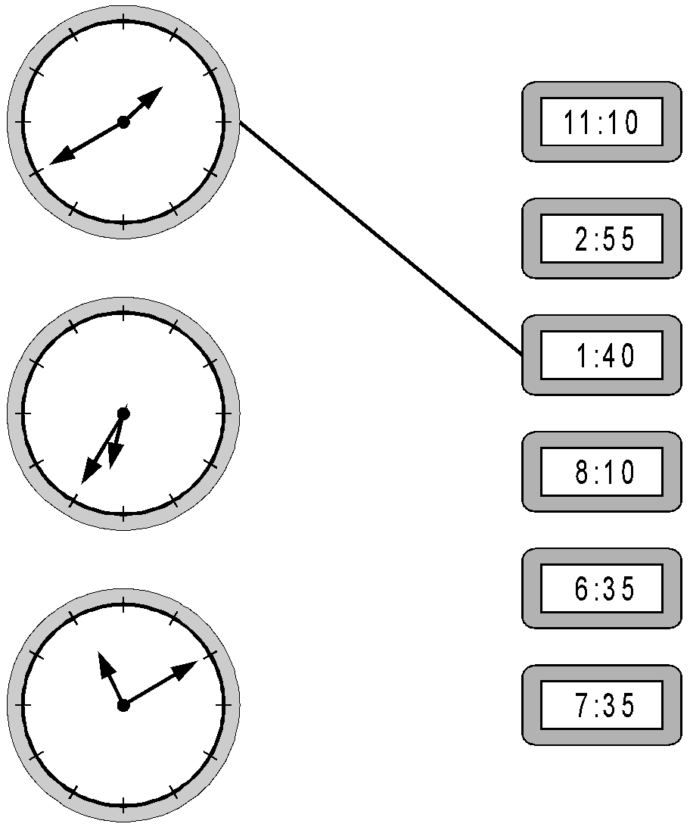
9 Here are three clock faces.
Match each clock face to the same time on a digital clock.

2 marks
3.0b

10 These are the radio programmes one morning.
Josh turns the radio on at 7:25am.
How many minutes does he have to wait for the Weather report?

minutes

The Holiday programme lasts for 40 minutes.
At what time does the Holiday programme finish?

am
2 marks
4.5a

11 This table shows the opening times of a pet clinic.
How many hours is the clinic open on Thursday?

hours

On which day is the clinic open for the longest time?

Liam takes his dog to the clinic on Saturday. He arrives at 9:25 am.
How many minutes is it before the clinic opens?

minutes
3 marks
5.10b

12 One length of a swimming pool is 25 metres.
How many lengths are there in a 150 metre race?

Six children swim 50 metre race.
Who finished first?

How many seconds faster was Dean than Fiona? seconds
2 marks
5.98b

13 Write these times in order, starting with the shortest.

24 days 1 month 10 weeks 48 hours

shortest
1 mark
5or6.10aa
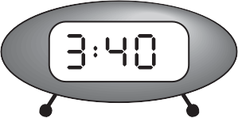
14 A clock shows this time.
PM

How long is it from this time until 5 pm?

What time was it quarter of an hour before the time on the clock?
pm

2 marks
6.6a
15 The time is 10:35 am.
Kate says,
‘The time is closer to 11:00 am than to 10:00 am’.
Explain why Kate is correct.

1 mark
6.7b
16 At what time does the castle close on Wednesday July 15th?

pm

For which months is the castle open seven days a week?

On Saturday March 8th John goes into the castle at 3pm.
He stays until closing time.

For how many hours does he stay in the castle? hours
3 marks
6.98a

17 Holly takes half an hour to walk from home to school.
She arrives at school at 8:25 am.
At what time did she leave home?

am
Dev leaves school at half past three.
He arrives home at ten past four.
How many minutes did it take him to get home?

minutes
2 marks
7.11a

18 Tom, Amy and Helen want to go on a boat trip.

Lark
50 minute trip

Tickets
£2.75
each
Heron
70 minute trip

Tickets
£3.50
each
Kestrel
90 minute trip

Tickets
£4.20
each
There are three boats.
How much does it cost altogether for three people to go on the Lark?

£

Tom and Amy go on the Heron.
They leave at 2.15pm.

At what time do they return? pm

Helen goes on the Kestrel and gets back at 4:15pm.

At what time did the boat leave? pm
3 marks
7.99b

19 Children run a 100 metre race on Sports Day.
Here are their times.

What is the winner’s time? seconds

Who has the time nearest to 16 seconds?

2 marks
7.96a

20 Children run a 100 metres race on Sports Day. Here are their times.
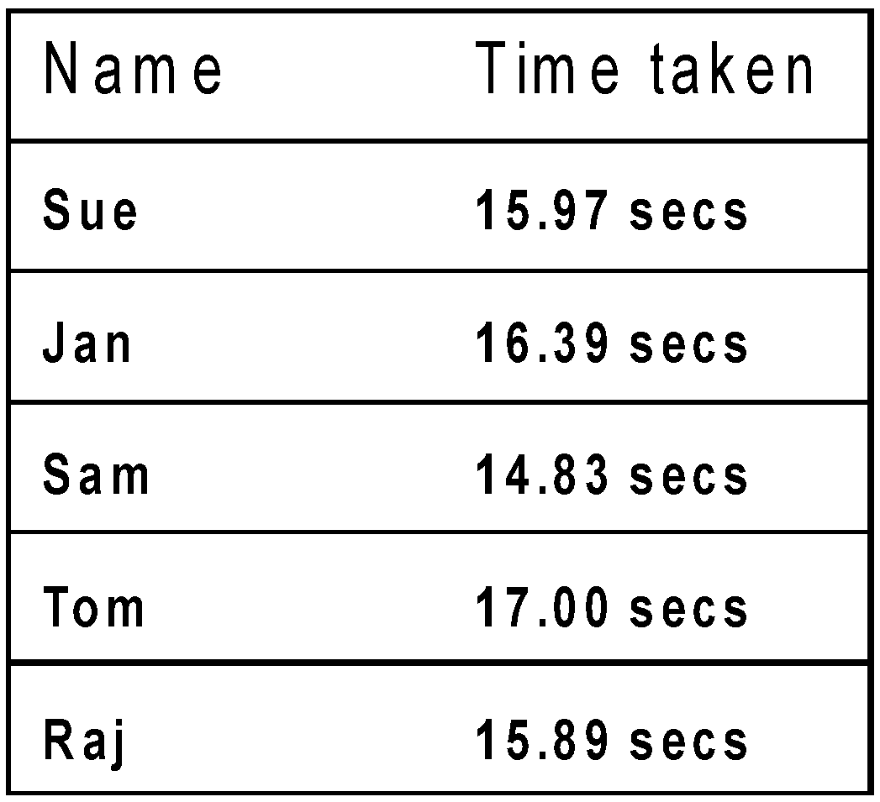

What is the winner’s time? seconds

Who has the time nearest to 16 seconds?

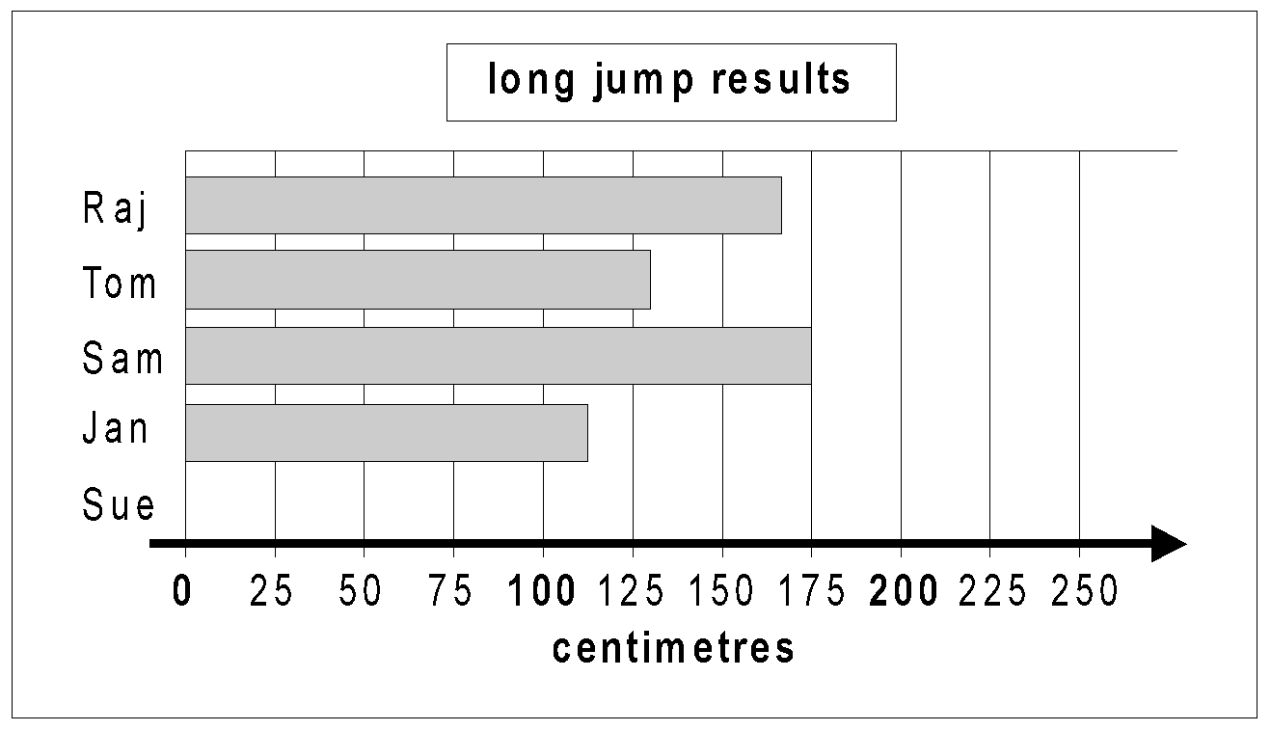
Here are their long jump results.

Sue jumped 212 cm.
Draw Sue’s long jump result on the graph.

Use the graph to estimate how much further Sam jumped than Jan.

^{cm}
2 marks
7.96a

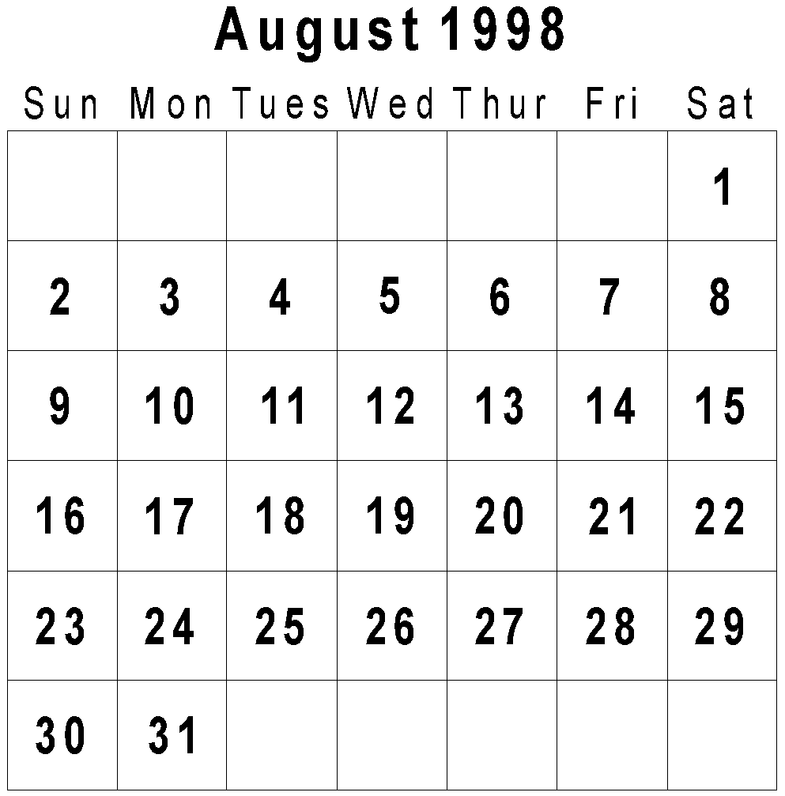
22 Here is the calendar for August 1998.
Simon's birthday is on August 20th.
In 1998 he had a party on the Sunday after his birthday.
What was the date of his party?

Tina's birthday is on September 9th.
On what day of the week was her birthday in 1998?

2 marks
8.99b
21 The table below shows five journeys a taxi driver made one day.

On journey number 5, the passengers shared the cost equally.

How much did each passenger pay? £

How many passengers made journeys of more than 10 km? passengers

The 12 km journey took 40 minutes.

What time did the taxi finish its journey? am
3 mark
8.12b

23 Here are the times of some television programmes.
Channel 1
7.00 Cartoon
7.15 Film
9.00 News
9.30 Weather
9.35 Sport
10.20 Drama
Channel 2
7.00 Local News
7.45 Quiz Show
8.30 Comedy
9.00 Hospital Drama
10.00 Pop Chart
10.40 Film
What is showing on Channel 2 at ten minutes to eight?

Tom watches Hospital Drama and then changes to Channel 1 at the end.

What is showing on Channel 1 when he changes channel.

The film on Channel 2 starts at 10.40
It lasts for one and a half hours.

At what time does the film end?
3 marks
8.97a
24 These are the opening times at Black Tower Castle.
How many hours is the castle
open on Saturdays?

hours
Alfie arrived at the castle at 5pm on a Thursday.

How long could he stay before closing time?
2 marks
9.13b

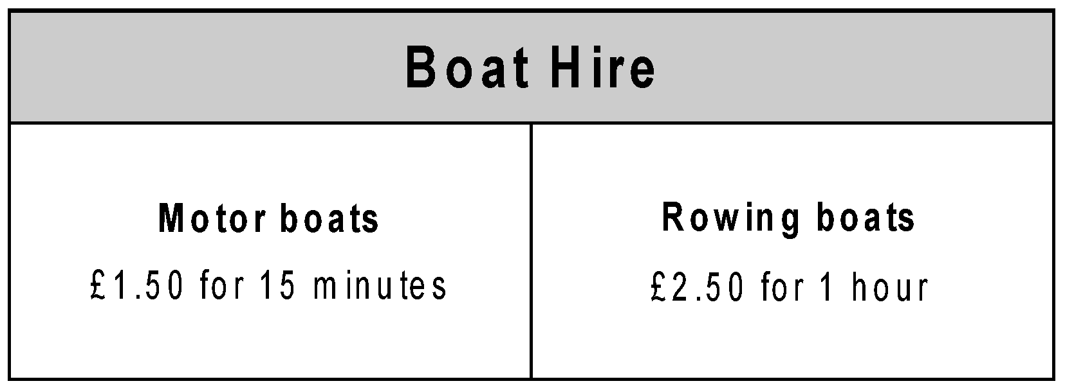
25 How much does it cost to hire a rowing boat for three hours?

£

Sasha pays £3.00 to hire a motor boat.
She goes out at 3:20 pm.
By what time must she return?

pm
2 marks
9.1b
26 This was the time on Selin’s watch when she set off for a walk.
What time did the watch show 20 minutes before this?

What time did it show an hour and a half after she set off
for the walk?

2 marks
10.1a

27 A film starts at 6:45pm.
It lasts for 2 hours and 35 minutes.
What time will the film finish?

pm
1 mark
11.4a

28 This table shows when flights take off at an airport.
How many flights take off between 3pm and 5pm?
How much later does the second flight to Paris take off than the first?

The flight to Dublin takes 50 minutes.
What time does it arrive in Dublin?

:
3 marks
11.9b

29 Kirsty ran a race in one and a half minutes.
Mina took 10 seconds longer.

How many seconds did Mina take to run the race? seconds
1 mark
12.12b

30 Joe goes skating every Saturday.
He went skating on Saturday January 1st.
Altogether, how many times did Joe go skating in January?

1 mark
12.11b
31 Jamie, Kate and Hassan run a 50 m race.
Kate’s time is 13 seconds.
Jamie finishes 5 seconds before Kate.
Hassan finishes 3 seconds after Jamie.
What is Hassan’s time in seconds?

seconds
1 mark
13.7b
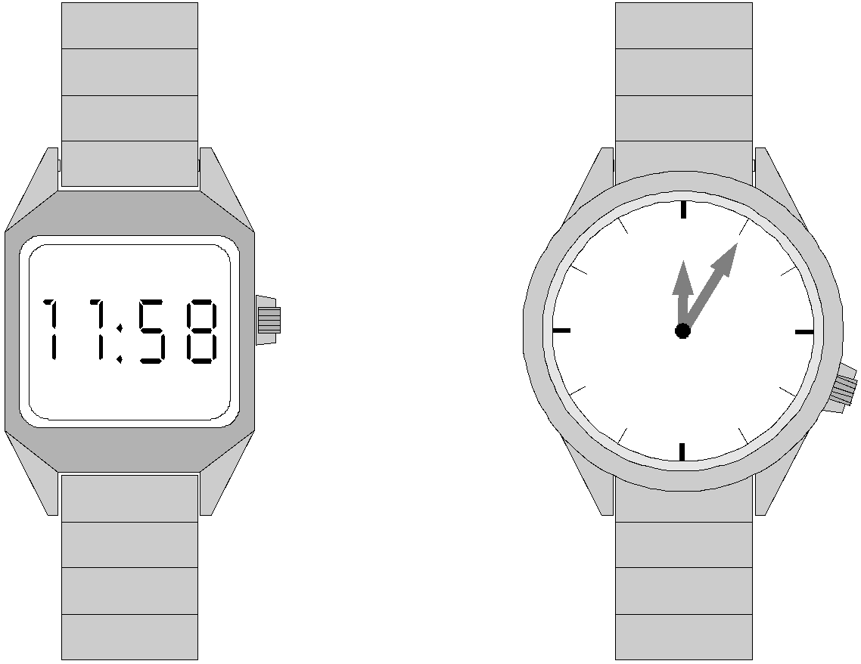
32 One of these watches is 3 minutes fast.
The other watch is 4 minutes slow.
What is the correct time?

1 mark
15.2b

33 Here is part of a time line.

Draw a line from each invention to the correct point on the time line.
One has been done for you.

2 marks
14.6a

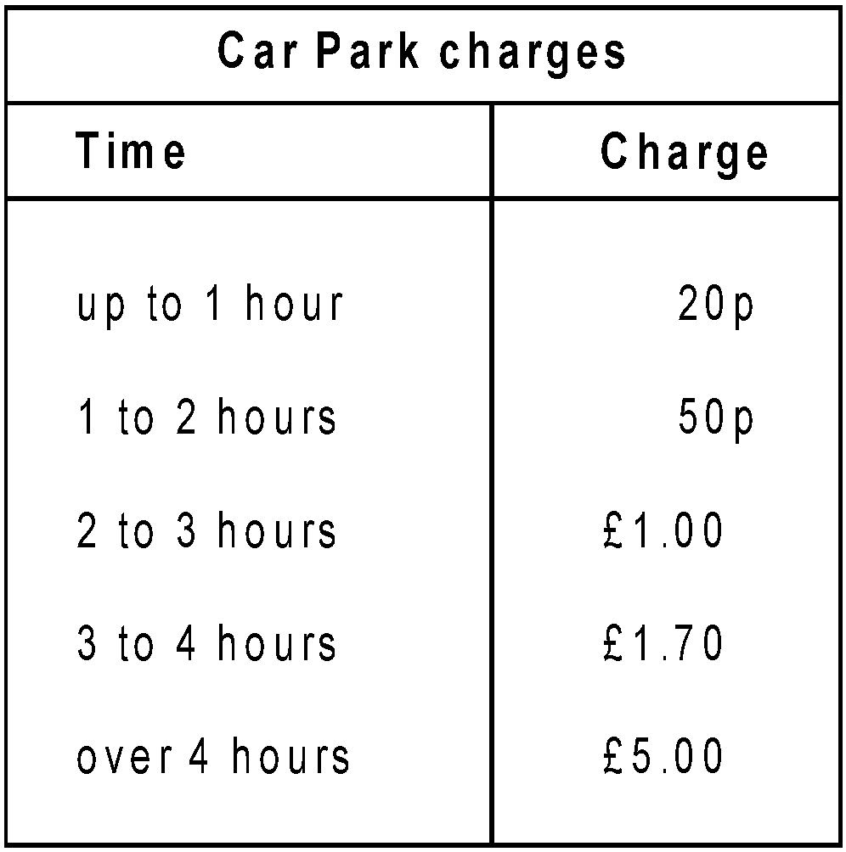
34 Emma parks her car at 9.30 am.
She collects the car at 1.20 pm.
How much does she pay?

Dan and Mark both use the car park.
Dan says,
‘I paid exactly twice as much as Mark but only stayed 10 minutes longer’.
Explain how Dan could be correct.

2 marks

14.99a

35 Some children ran in two races on sports day.
Here are their times.
Who finished the 100m race in second place?

In the 800m race, how many seconds did Barry finish ahead of Elise?
seconds

2 marks
14.3a
37 These are all times on the same morning.
A 7:56am B quarter to eight C six minutes to eight D half past seven
Write the letters for the times in order, starting with the earliest.

1 mark
15.12a

36 Here is part of the timetable for Class 6 on a Monday.

Look at the timetable.
How long is it from the end of break to the start of lunch?

Nisha leaves the Science lesson after 25 minutes.
Then she goes to the dentist.

What time does she leave the Science lesson?
2 marks
15.8a

38 Here are the start and finish times of some

children doing a sponsored walk.

How much longer did Claire take than Tim?

minutes
1 mark
17.?b

38 This graph shows the distance Alfie and Chen walked in an afternoon.
They started at 1:45pm and had two breaks.
How many kilometres did they walk between the first and second breaks?

_{km}

At what time did Alfie and Chen start their second break?

2 marks
17.13a

40 Here is part of the morning train timetable from Perth to Midland in Australia.
What time is the first train from Maylands that stops at Success Hill?

Maylands :

Mr Evans is in Perth and wants to be in Midland by 08:00
What is the time of the latest train he can take from Perth?

Perth :
2 marks
20.11b

41 Here is a part of a train timetable.
How long does the first train from Edinburgh take to travel to Inverness?

Ellen is at Glasgow station at 1:30pm.
She wants to travel to Perth.
She catches the next train.

At what time will she arrive in Perth?
2 marks
23.4a

