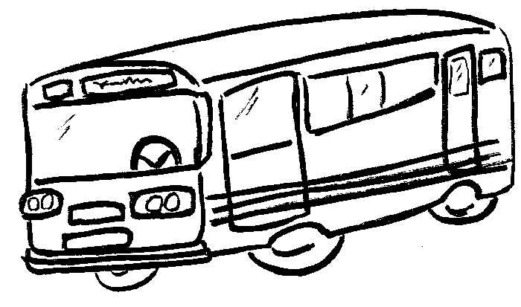
Timetables 1 challenge 1

Buses leave Shakespeare Junior School every 20 minutes starting at 08:00 in the morning. It takes 10 minutes to get to the railway station and a further 15 minutes to get to the airport. Complete the timetable.
Shakespeare Junior School | Eastleigh Railway Station | Southampton Airport
08:00 | 08:10
08:20 |  | 08:45
 | 08:50 | 09:05
09:00

Timetables 2 challenge 2 and 3

Buses leave Shakespeare Junior School every 20 minutes starting at 08:00 in the morning. It takes 9 minutes to get to the railway station and a further 14 minutes to get to the airport. Complete the timetable.
Shakespeare Junior School | Eastleigh Railway Station | Southampton Airport
08:00 | 08:09
08:20 |  | 08:43
 | 08:50
09:00

