Before you begin, practise your times tables on Time Tables Rockstars for 20 minutes.
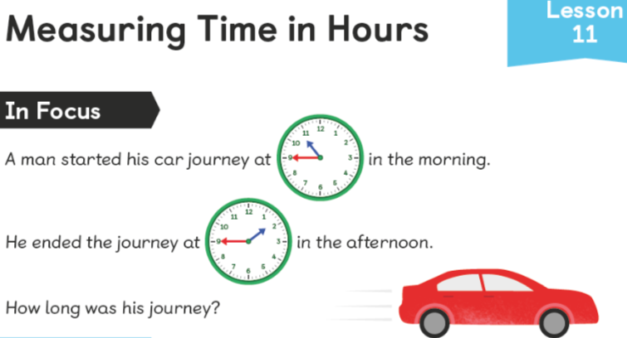
My friend said that because the minute hand has not moved, you only need to count the hours that have passed. Is this true? Is there a way we can check?

What might time look like if we place it on a timeline?

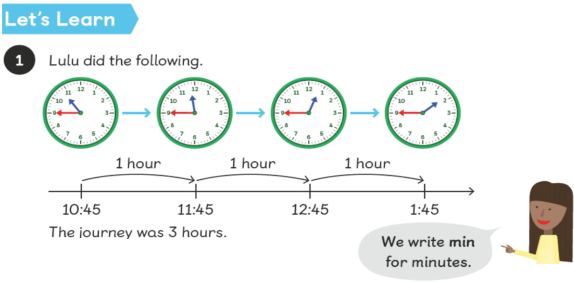
Is this a helpful tool to see how much time has passed?
What intervals do you think would be helpful to mark on a timeline:
5 minutes, 15 minutes? What might this depend on?

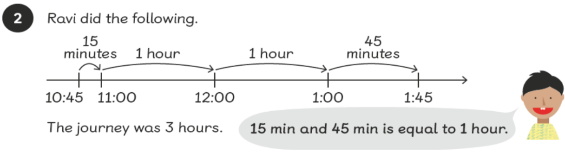
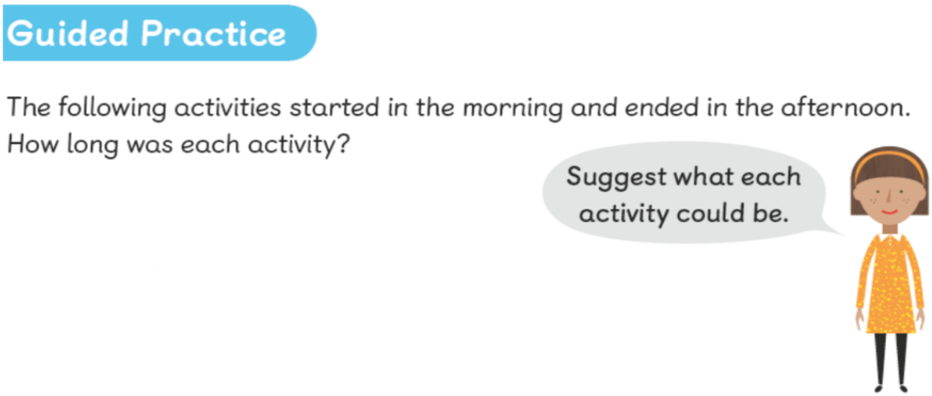
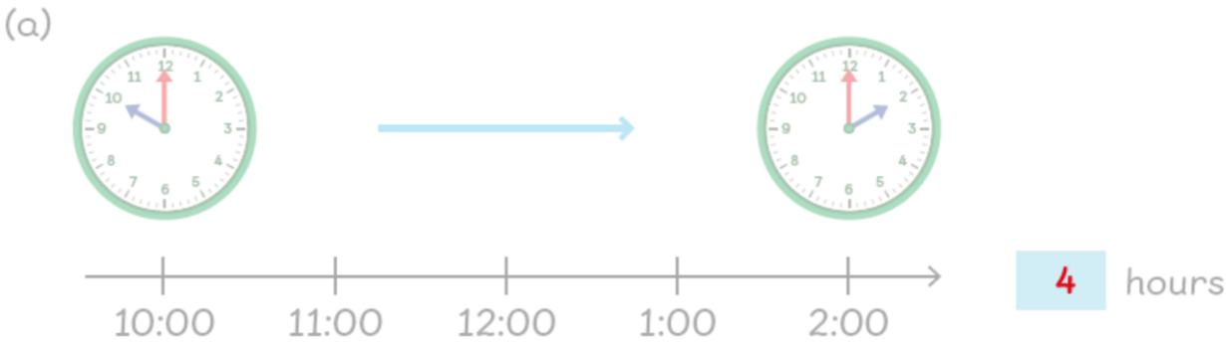
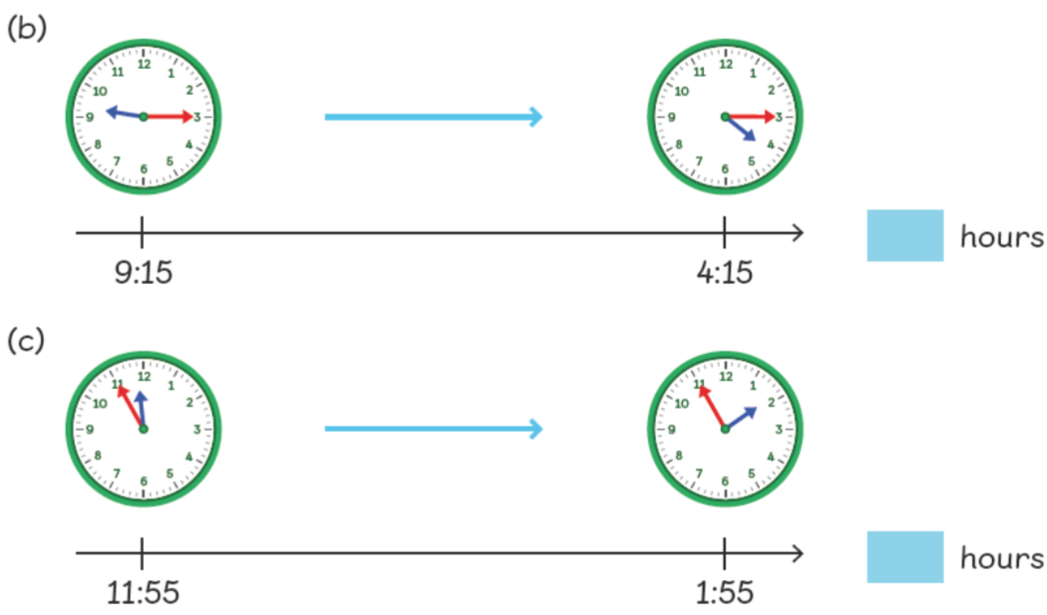
What if the last activity finished at 2:00?

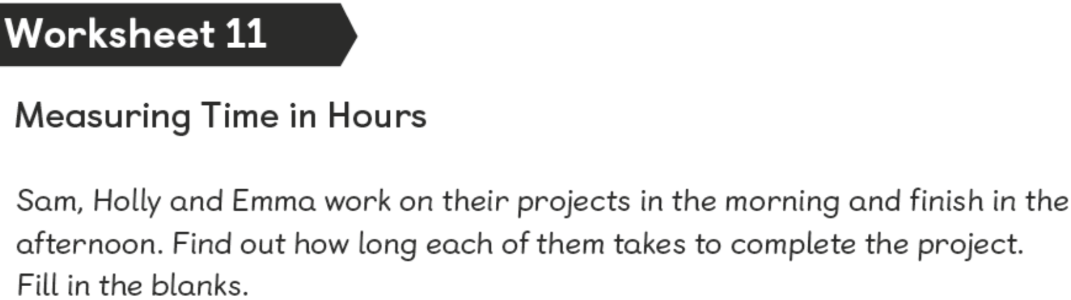
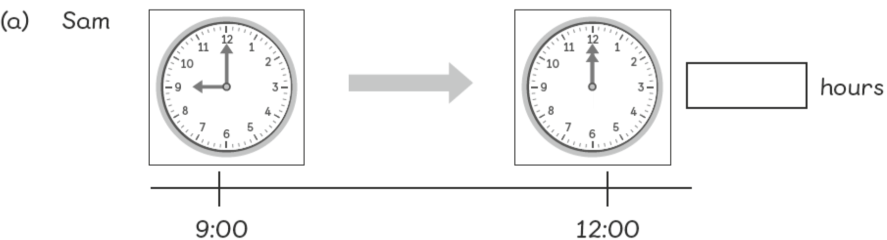
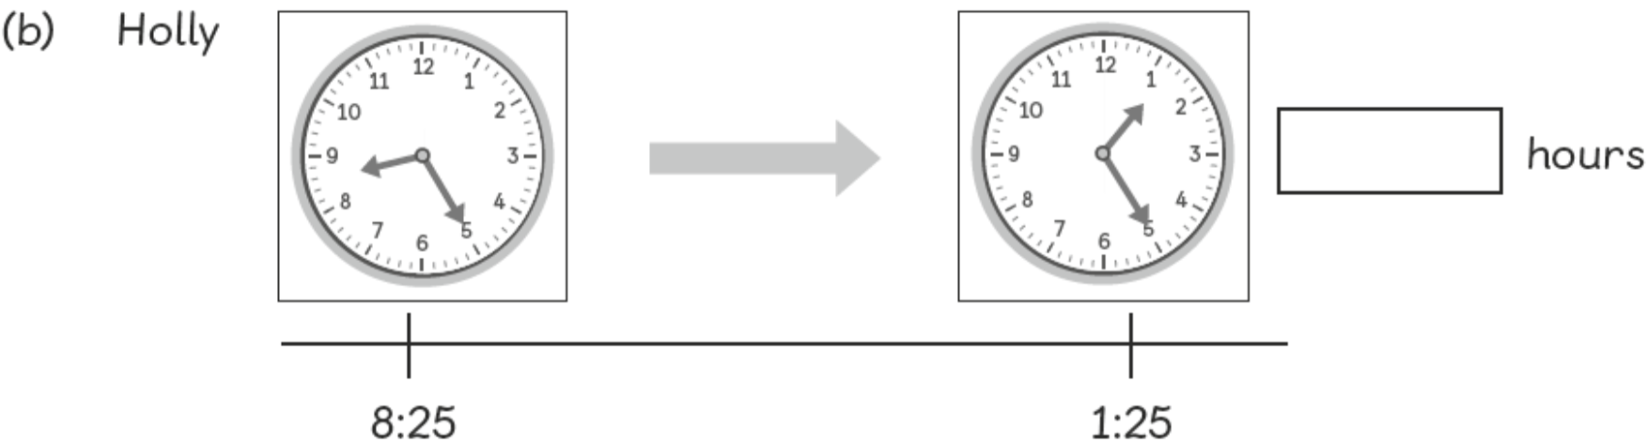
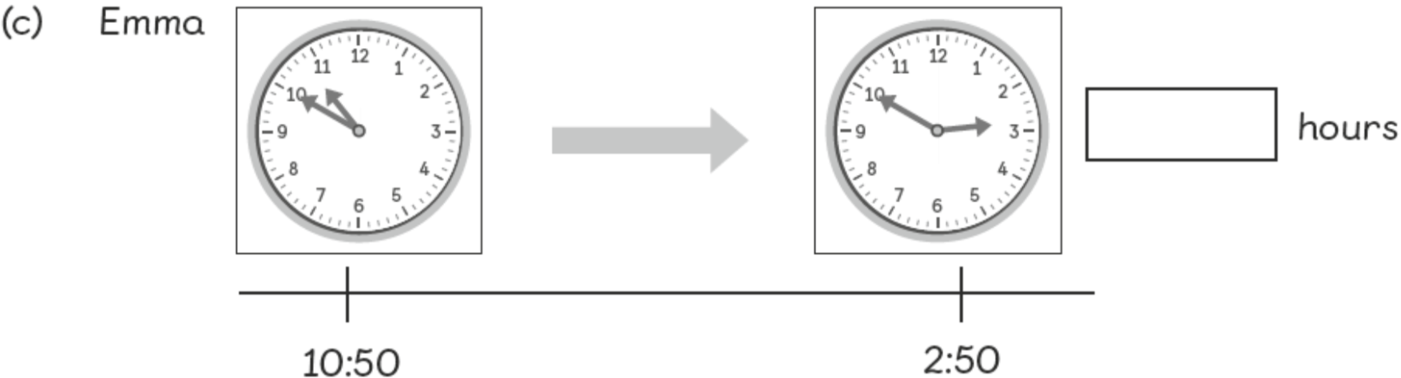

Extension
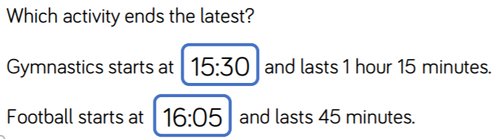
Answers
a)
b)
c)

Extension

