Before you begin, practise your times tables on Time Tables Rockstars for 20 minutes.
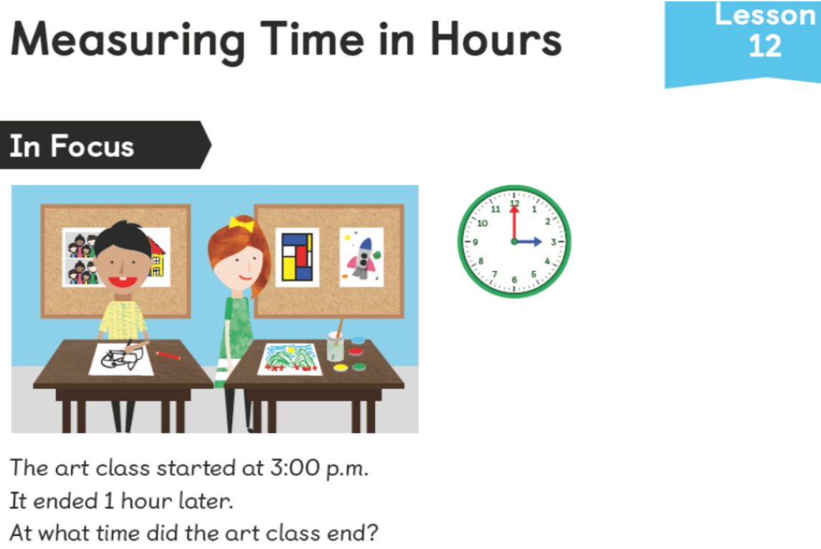
What does ‘1 hour later’ mean?
Can we rephrase it?

‘1 hour later’ is actually the same as ‘after 1 hour’

If possible, draw a timeline to show the amount of time passed.
What if the class finished 3 hours later?
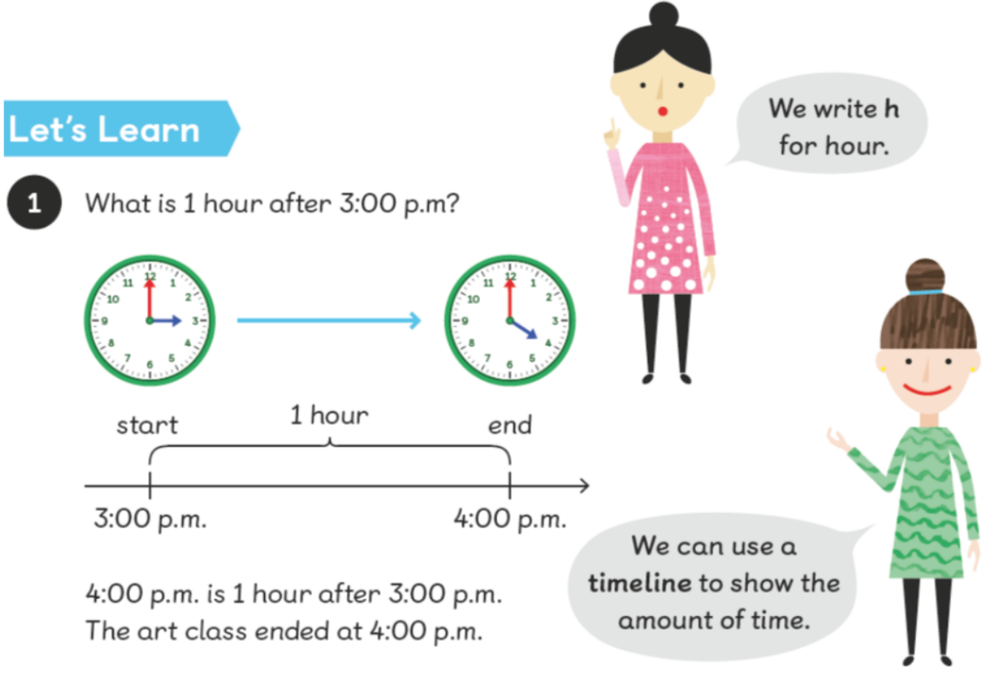
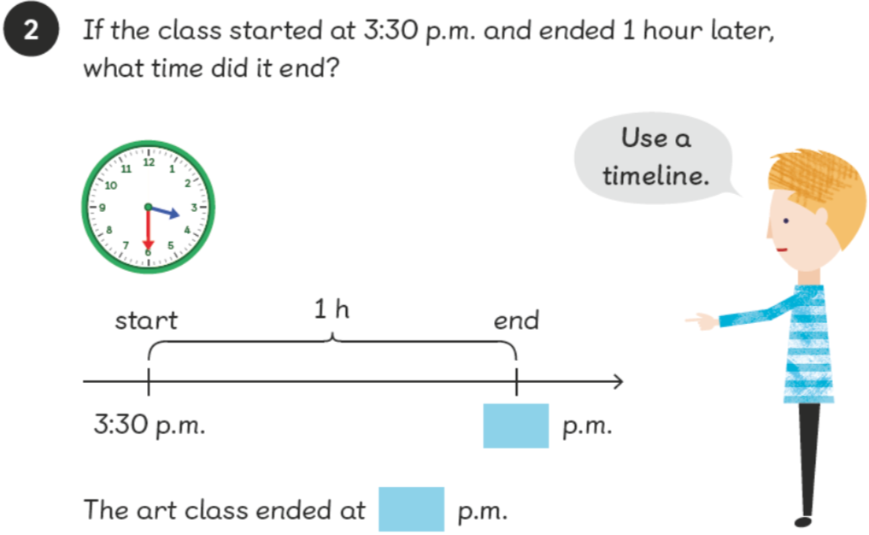
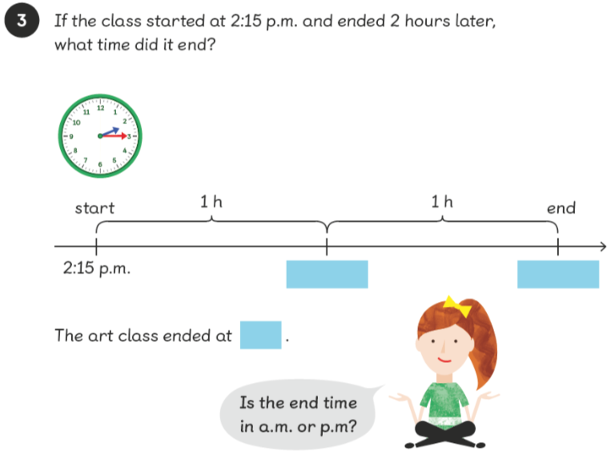
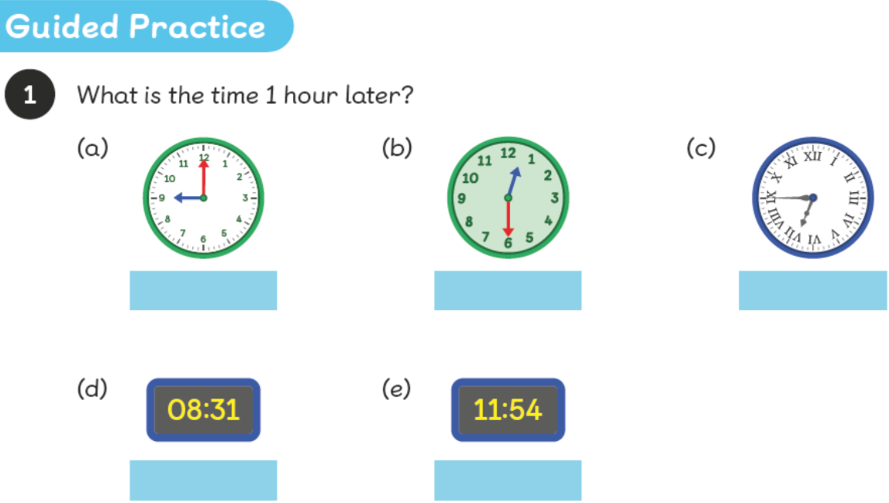
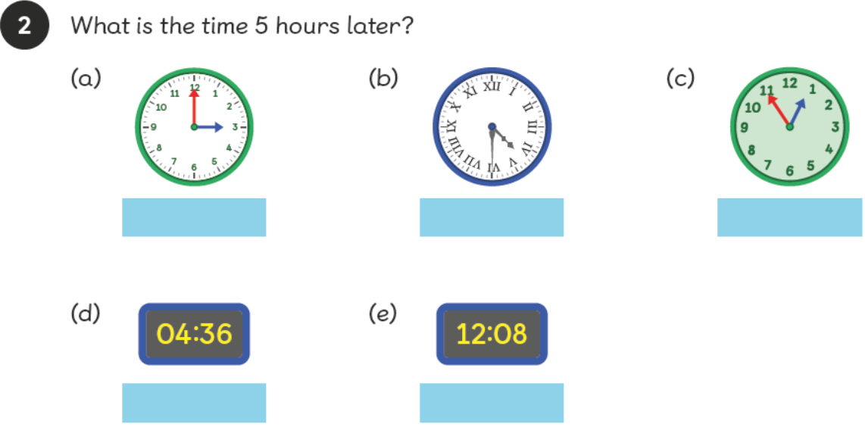
What do you notice about the minutes when the only thing that changes is the amount of hours?

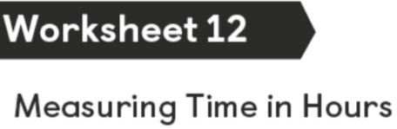
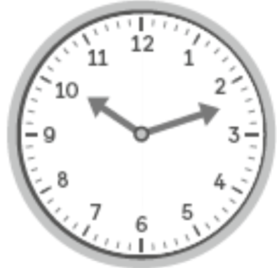
What is the time?

What will the time be 2 hours later?

What will the time be 6 hours later?

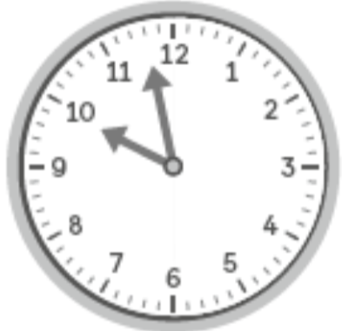
What is the time?

What will the time be 2 hours later?

What will the time be 6 hours later?

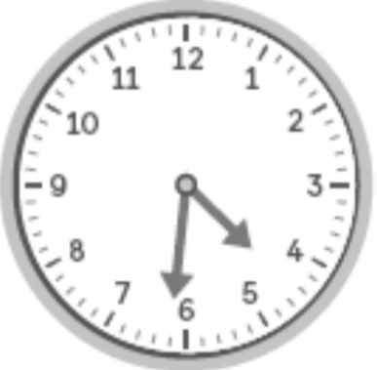
What is the time?

What will the time be 2 hours later?

What will the time be 6 hours later?

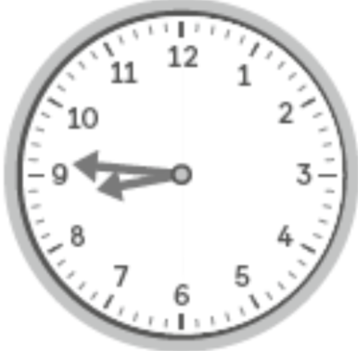

What is the time?

What will the time be 2 hours later?

What will the time be 6 hours later?

What will the time be 2 hours later?

What will the time be 6 hours later?

What will the time be 2 hours later?

What will the time be 6 hours later?

Extension
Create a word problem similar to the one in the ‘In Focus’ task.

