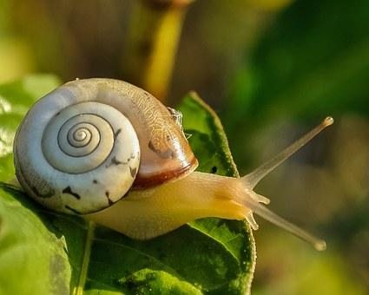
Year 2 Comprehension
Challenge 1
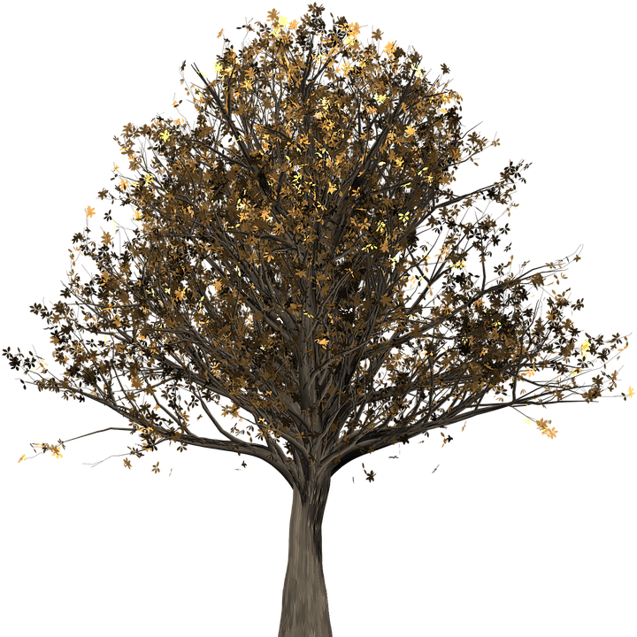
Microhabitats

Useful words
binoculars
creatures
millipedes
Microhabitats
A habitat is where an animal or plant chooses to make its home. This might be a woodland, a desert or the rainforest.
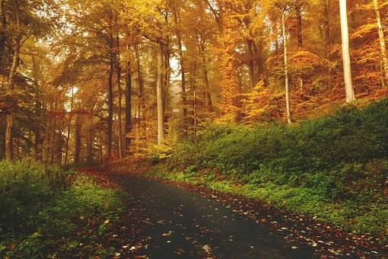
What is this habitat?
In every habitat, there are lots of microhabitats, such as trees, ponds and hedges.
This booklet will help you find out about some of the microhabitats in a woodland…
Questions
- Tick three examples of habitats.

Animal Woodland
Desert Rainforest

- Write one example of a microhabitat.

A tree
What lives on a tree?
You might find some birds’ nests up the top of a tree, where robins, wrens or owls live.
Under the bark, you can find woodlice.
On the leaves might be mites or caterpillars.
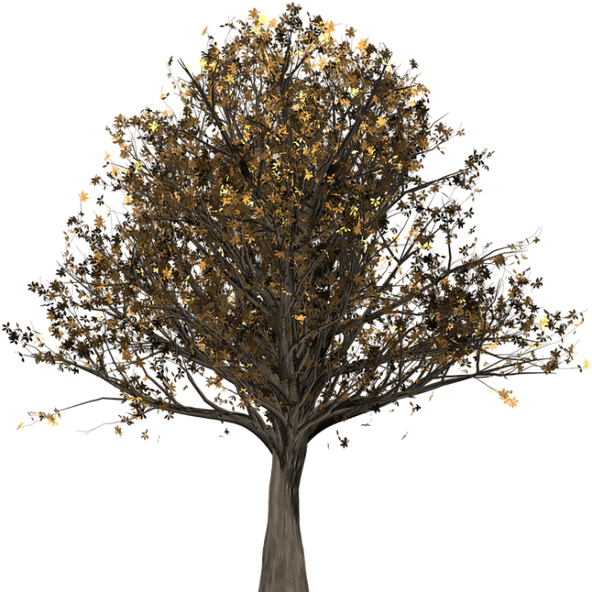

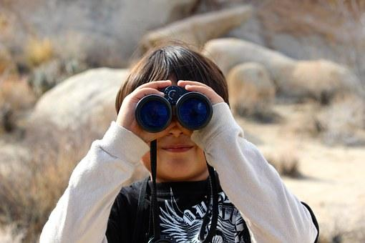
How can I explore it?
Use binoculars.
Gently pull off a bit of loose bark.
Sweep a net through the leaves.

Questions
- Write 3 birds you might find at the top of a tree.

- On which part of the tree will you find a mite?

- What should you use to sweep through the leaves?
Leaf-Litter
What is it?
There are lots of leaves on the woodland floor. This is called leaf-litter.

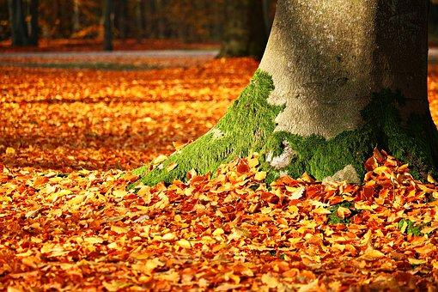
How can I explore it?
Use a paintbrush to hunt in the leaves and brush any creatures into jars.
Or collect a pile of leaves and put them on large white paper.

What will I find?
You might find beetles, slugs, snails and many more!

Questions
- Where will you find leaf litter?

- What will you need to take with you to help you look in the leaf litter? Tick three.

Paintbrush Jars

White paper Spade

- Find and copy one word meaning ‘gather.’

Under a Log
How can I explore it?
Choose small logs and gently roll them over.
Collect some of the mini-beasts.
Don’t forget to put them back!
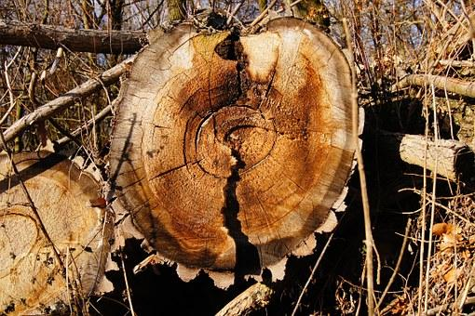

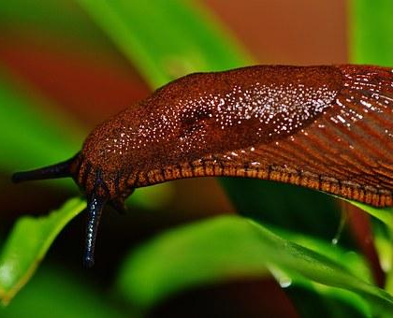
What will I find?
Under a log there is a lot of wood and insects to eat. It is a perfect spot to hide. You might find millipedes, slugs or snails.

Questions
- What should you not forget?

- Why do you think you should choose small logs?

- Why do some creatures choose to make their home under logs? Write two reasons.

