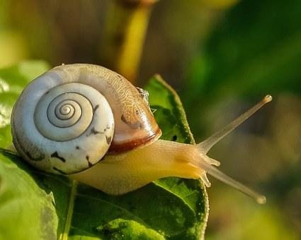
Year 2 Comprehension
Challenge 2
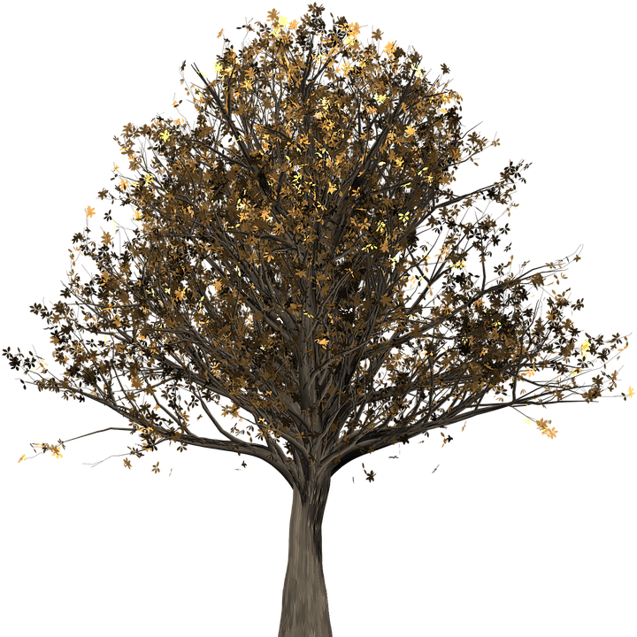
Microhabitats

Useful words
binoculars
creatures
predators
Microhabitats
A habitat is the place where an animal or plant chooses to make its home. This might include a woodland, a desert, the ocean or the rainforest.
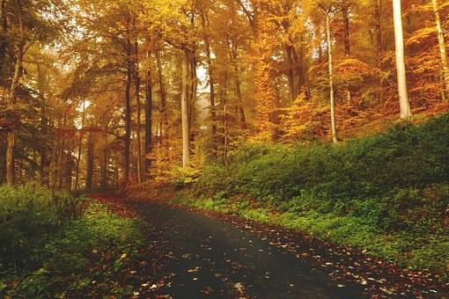
What is this habitat?
In every habitat, there are lots of microhabitats, such as trees, ponds and hedgerows.
This booklet will help you find out about some of the microhabitats you might come across in a woodland…
Questions
- Tick three examples of habitats.

Animal Woodland
Ocean Rainforest

- Write one example of a microhabitat.

A tree
What lives on a tree?
You might find some birds’ nests or holes up the top of a tree, where robins, wrens, owls or woodpeckers live.
Under the bark, you can find woodlice feasting on the dead, damp wood.
On the leaves might be mites, moths or caterpillars.
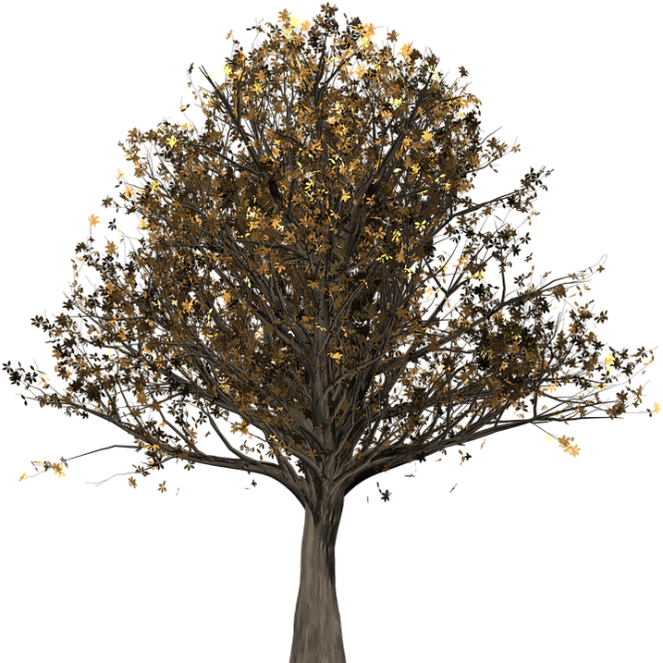

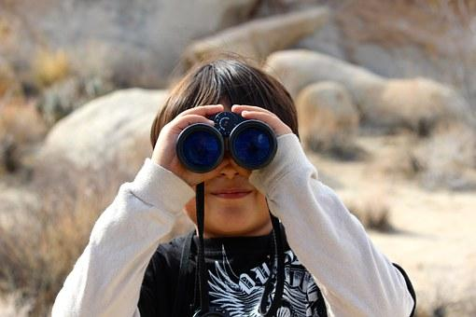
How can I explore it?
Use binoculars. (Make sure you wait quietly!)
Gently pull off a tiny bit of loose bark.
Sweep a net through the leaves and see what you find in your net.

Questions
- Write 3 birds you might find living on the top of a tree.

- On which part of the tree will you find a mite?

- What should you use to sweep through the leaves?
Leaf-Litter
What is it?
The floor of a woodland is covered in leaves. These leaves are the perfect home for mini-beasts!

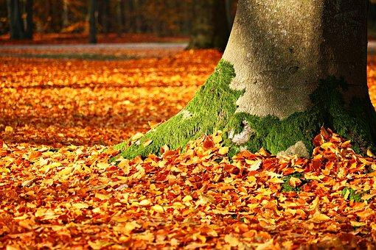
How can I explore it?
Ask your teacher to take you somewhere you will find lots of leaves.
Use a paintbrush to hunt gently through the leaves and brush any creatures into jars.
Or collect a pile of leaves and spread them out on large white paper.

What will I find?
You might discover beetles, slugs, snails, centipedes, millipedes, earwigs, caterpillars and many more!

Questions
- Where will you find leaf litter?

- What will you need to take with you to help you look in the leaf litter? Tick three.

Paintbrush Jars

White paper Spade

- Find and copy one word meaning ‘gather.’

Under a Log
How can I explore it?
Choose small logs and gently roll them over.
Collect some of the mini-beasts by brushing them into a pot.
Don’t forget to put them back before you roll the log back down!
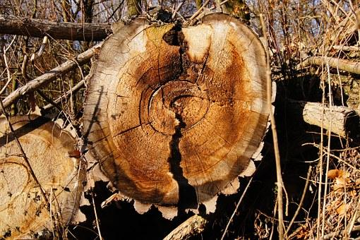

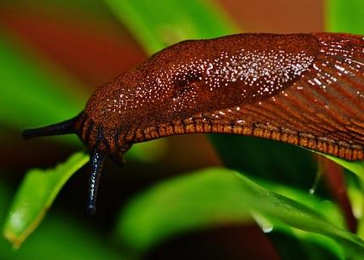
What will I find?
Under logs there is lots of dead wood and other insects to eat and it is a perfect spot to hide from predators. You might find millipedes, slugs or snails.

Questions
- What should you do before you roll the logs back?

- Why do you think you should choose small logs?

- Why do some creatures choose to make their home under logs? Write two reasons.

