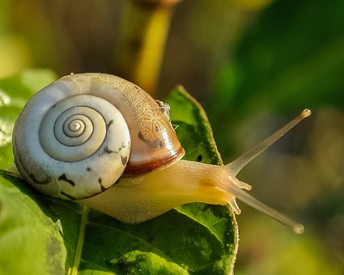
Year 2 Comprehension
Challenge 3
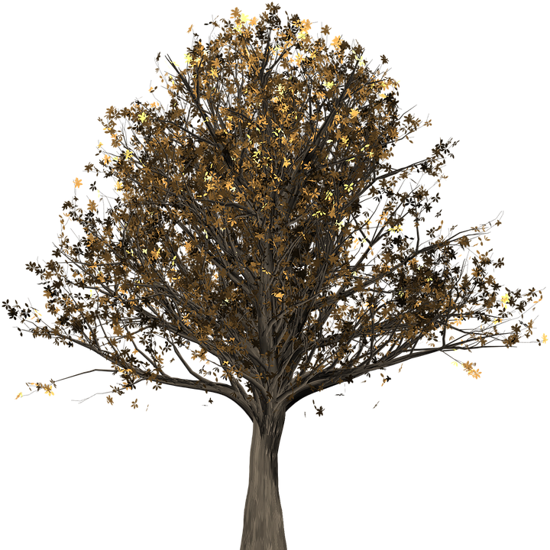
Microhabitats

Useful words
apartment
predators
amphibians
Microhabitats
A habitat is the place where an animal or plant chooses to make its home. This might include a woodland, a desert, the ocean or the rainforest. Lots of different animals live in every habitat, because they rely on each other for things such as food.
What is your micro-habitat?
In every habitat, there are lots of microhabitats. For example, you might live in a town. That would be your habitat. If you live in an apartment, then the apartment is your microhabitat!
This booklet will help you find out about some of the microhabitats you might come across in a woodland…
Questions
- Tick three examples of habitats.
Apartment Woodland
Ocean Rainforest

- Why do lots of animals live in one habitat?

A tree
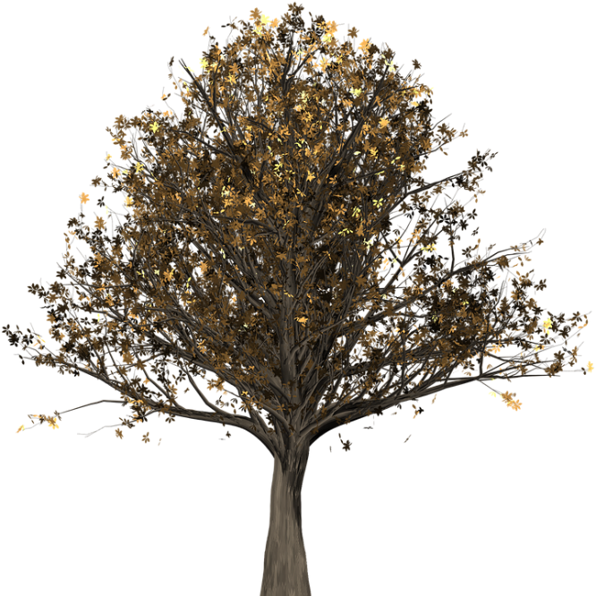
What lives on a tree?
- You might find some birds’ nests or holes up the top of a tree, providing shelter to robins, wrens, owls or woodpeckers.
- Living beneath the bark, you are likely to discover woodlice feasting on the dead, damp wood.
- Making their homes on the leaves might be mites, moths or caterpillars.

How can I explore it?
- Use binoculars to peer up the top. (Make sure you wait patiently and quietly!)
- Very gently pull of a tiny piece of loose bark.
- Sweep a net through the leaves and see what you find in your net.

Questions
- Write 3 birds you might find living on the top of a tree.

- On which part of the tree will you find a mite?

- Find and copy one word meaning ‘carefully.’
What is it?
Have you ever noticed that the floor of a woodland is covered in leaves? In the autumn, the leaves fall off the trees and spend the rest of the year decomposing (rotting) on the ground. These leaves are the perfect home for a wide selection of mini-beasts!
Leaf-Litter

How can I explore it?
- Ask your teacher to take you somewhere you will find lots of leaves.
- Use a paintbrush to hunt gently through the leaves and brush any creatures into jars.
- Or collect a pile of leaves and spread them out on large white paper to see what scurries across the sheet!
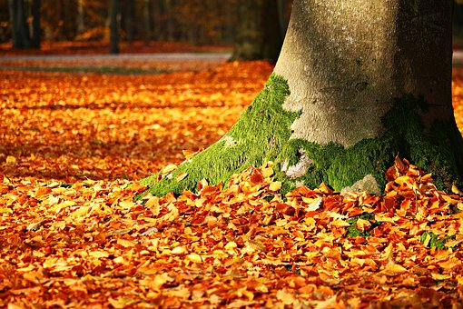

What will I find?
You might discover beetles, slugs, snails, centipedes, millipedes, earwigs, caterpillars and many more!

Questions
- What does ‘decomposing’ mean?

- What will you need to take with you to help you look in the leaf litter? Tick three.
Paintbrush Jars

White paper Spade

- Find and copy one word meaning ‘runs.’

How can I explore it?
- Make sure you take some grown-ups with you.
- Choose small logs and gently roll them over.
- Collect some of the mini-beasts by brushing them into a pot.
- Don’t forget to put them back before you roll the log back down!
- Ask a grown-up to help you move larger logs.
Under a Log
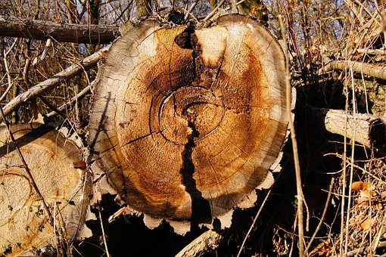

What will I find?
A surprising number of creatures like to live underneath logs, where it is very damp. There is lots of dead wood and other insects to eat and it is a perfect spot to hide from predators. You might find millipedes, slugs, snails or even amphibians, like frogs!

Questions
- Who should you take with you to hunt under logs?

- Why do you think you need to choose small logs?

- Why do some creatures choose to make their home under logs? Write two reasons.

