Maths Day 5
There are __ apples in each row.
There are __ rows.
__ + __ + __ = __
There are __ apples altogether.

There are __ stars in each row.
There are __ rows.
__ + __ + __ = __
There are __ stars altogether.

There are __ turtles in each row.
There are __ rows.
__ + __ + __. + __ = __
There are __ turtles altogether.

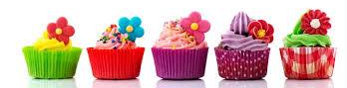 | There are __ cupcakes in each row.  There are __ rows.  __ + __ + __ = __  There are __ cupcakes altogether.

