Nursery - Spring/Easter Homework
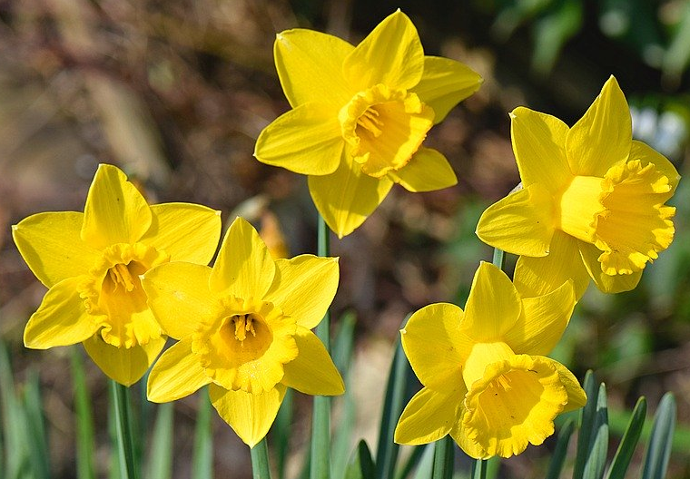
Lots of flowers start to grow in spring. Can you draw a picture of some flowers you have seen? What colour are they? Can you draw the petals and the stem?

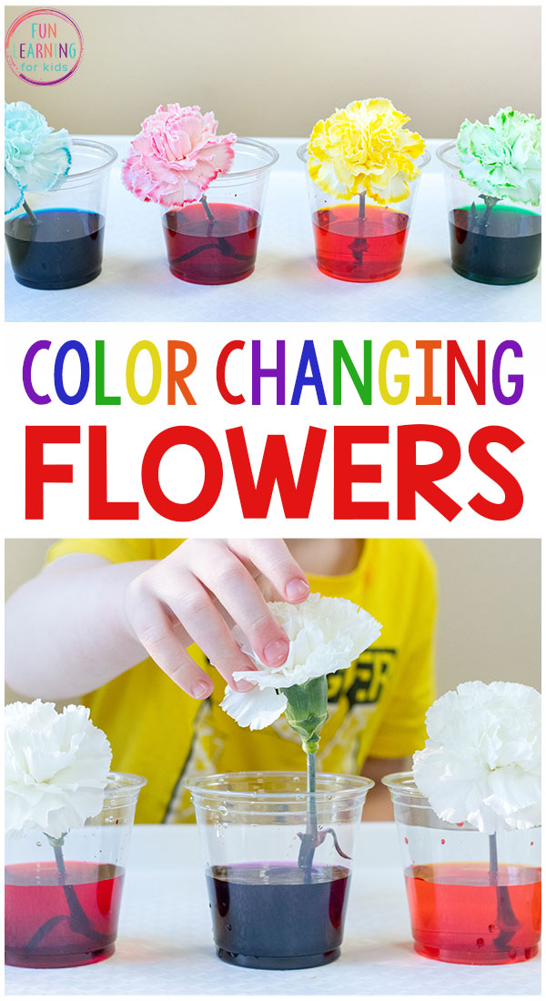
Try making an Easter basket to hold some eggs. You could use an empty box and decorate it with markers or paint. Can you draw some Easter pictures to put on your basket? This could be Easter eggs, flowers, bunnies or chicks.

Find a flower (preferably white), put it in a glass of water and add some food colouring to the water. Watch the flower over a week and see what happens to the flower. What happened to the flower? What colour was the flower? What colour did it change to?

Draw some Easter eggs onto paper (or print some off)
Colour in the eggs in bright colours.
What colours did you use?
Cut out the pictures of Easter eggs. Get someone in your family to hide them around your house. Go on an Easter egg hunt!
How many eggs can you find?

