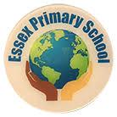
Holiday Homework Tasks
April 2020 Reception Class
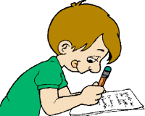  Writing and Drawing  Record in your book. | We all learnt how to wash our hands carefully.  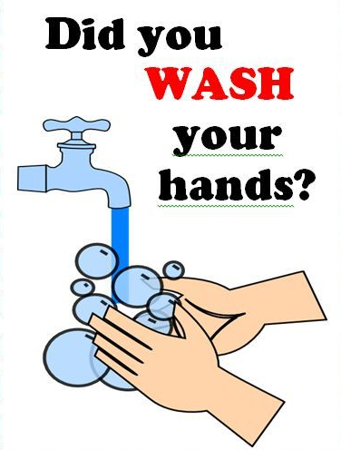  Write a sentence about why it is important that we wash our hands.  Draw: A poster about washing your hands.  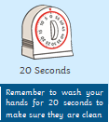  Don’t forget the soap!  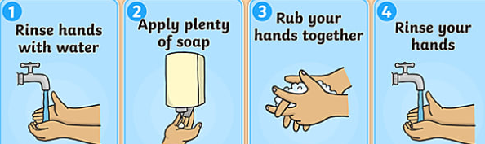
You need to work on each of these activities every day.
Reading | Remember to read every day!  It’s really important to show your family how good you are at reading your book!  Practise reading all the high frequency words. (You will find the words list inside your reading record book.)
Spoken Language | With your grownups try to make a model basket to hold some Easter treats! You could use an empty cardboard box and decorate it with paints or colourful Easter pictures.
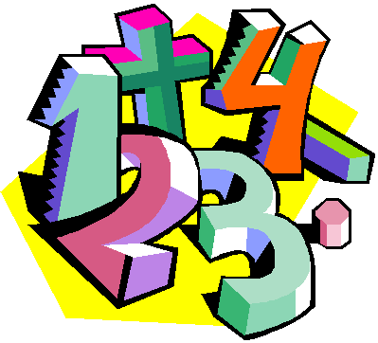  Numeracy | Write these number sentences in your homework book and solve these problems. 2+2=, 4+3=, 5+3=, 6+2=, 4+4=, 7+2=, 8+2=,  6-2=, 5-3=, 4-4=, 7-3=, 8-3=, 4-2=, 6-6=, 5-5=  Use objects around your home to solve these problems.
Handwriting | Practise writing all the letters of the alphabet.  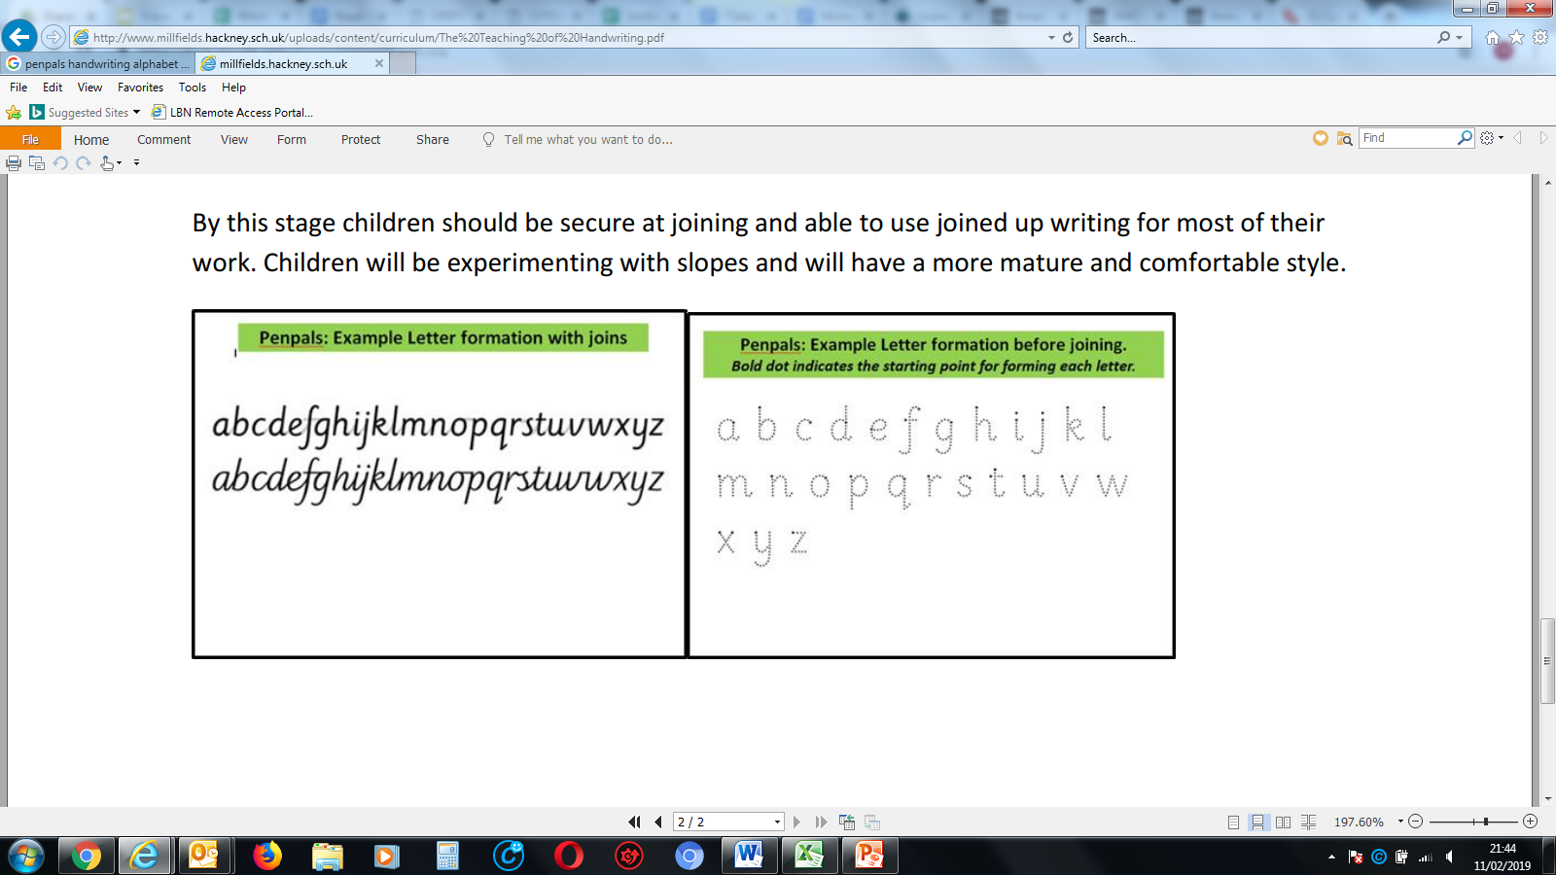
Next half term we will be learning about different ‘Fairy tales’.
(The frog Prince, Hansel and Gretel, Three Billy Goats Gruff, Jack & the Beanstalk)
Read your favourite story from the list.
Draw your favourite characters from the story.
Write in simple sentences why they are your favourite characters.

