ENGLISH
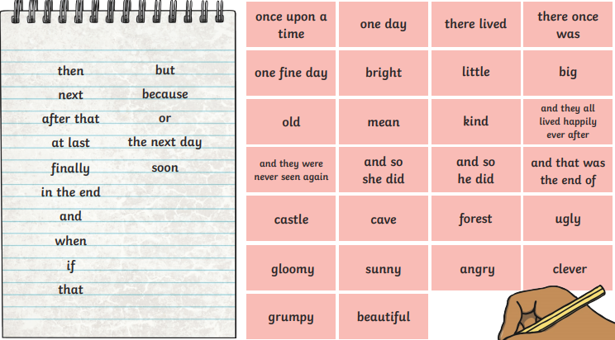
LO: To write the middle of a traditional tales
Checklist:
Used time conjunctions to move on to the next part of the story
Describe the other characters
Included a problem
used speech
Used adjectives
Today you will be writing the middle of the traditional tale, Jack and the Beanstalk. Use the following checklist to help you write the middle.

Please write the middle of the story here:

