HH00236_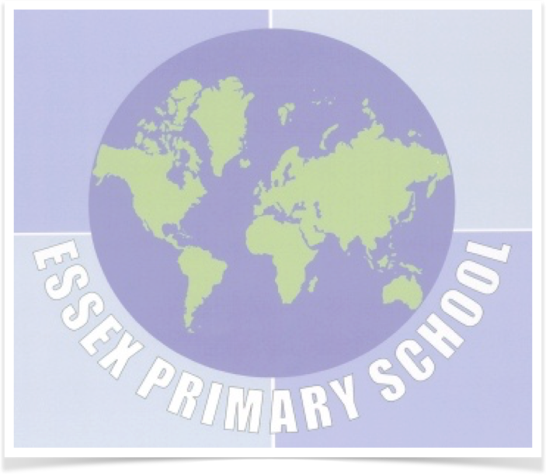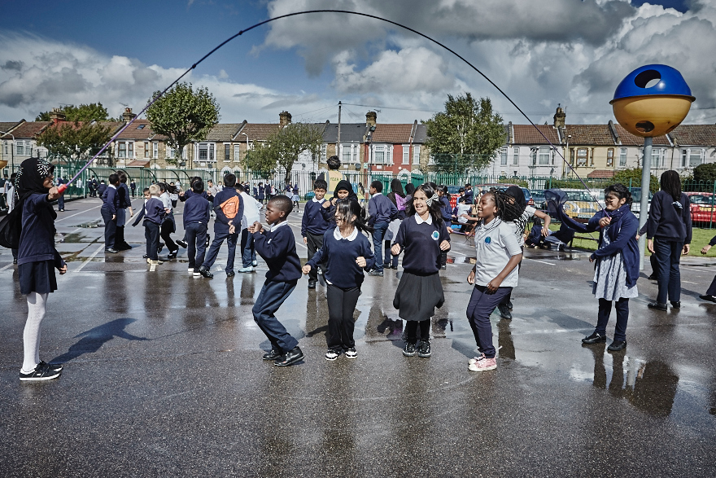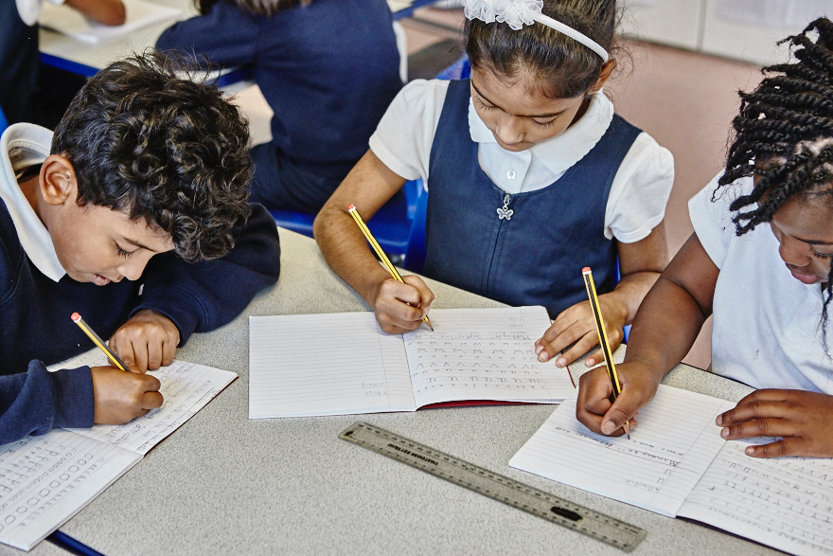

**Computing**

[](http://www.google.co.uk/url?sa=i&rct=j&q=&esrc=s&source=images&cd=&cad=rja&uact=8&ved=0ahUKEwjvz8_Qs9DRAhXIshQKHS9rD38QjRwIBw&url=http://nwamotherlode.com/archives/category/what-husbands-really-think&psig=AFQjCNF91pN4sLBQcLXpaLjA2c-1aSmpng&ust=1484990669800394)

Children will create their very own holiday e-card using ICT.

Also, they will plan and present a meteorological report using technology. Computing will also be included within all subjects, with some lessons delivered through Google Classroom.

**Maths**

In Maths we will aim to master:

* Area and perimeter
* Money
* Time
* Symmetry
* Co-ordinates and position
* Data handling
* Shape and space
* Problem solving.

Children must learn their times tables off by heart up to 12x12.

[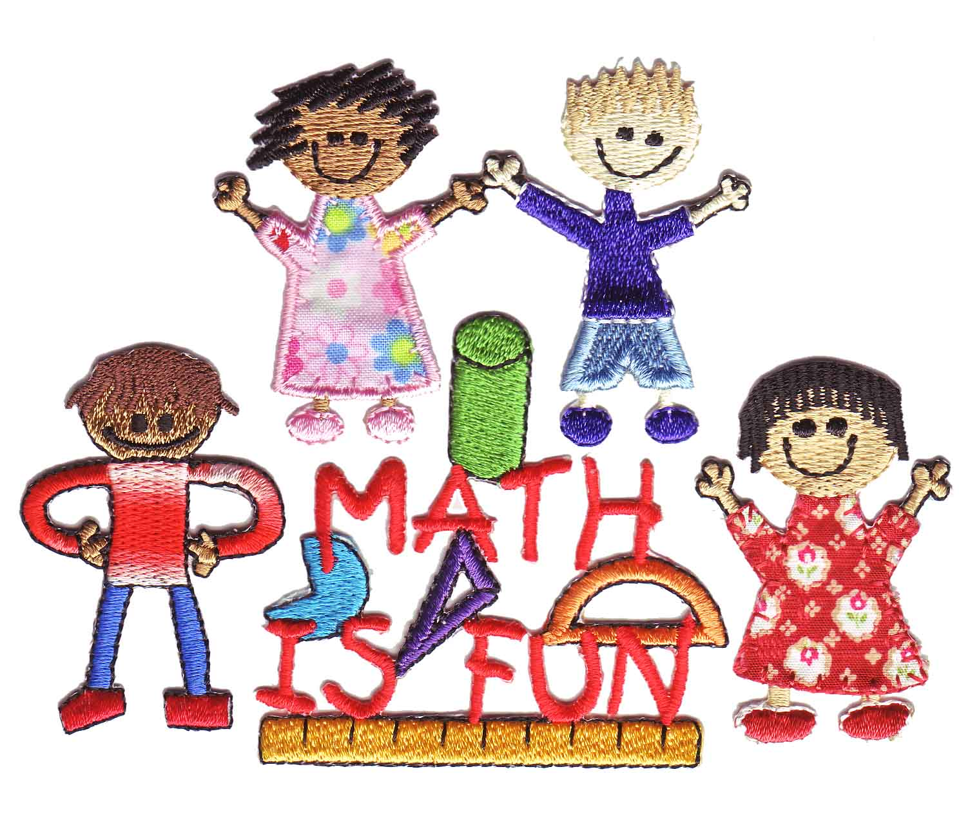](http://www.google.co.uk/url?sa=i&rct=j&q=&esrc=s&source=images&cd=&cad=rja&uact=8&ved=0ahUKEwjKtb78rNDRAhWDPRQKHZF-BdoQjRwIBw&url=http://www.clipartkid.com/clip-art-of-math-in-primary-school-students-cliparts/&psig=AFQjCNGsvAFr1O3-BrHlYzQEBOu73UpoAg&ust=1484988913636669)

.

[](http://www.google.co.uk/url?sa=i&rct=j&q=&esrc=s&source=images&cd=&cad=rja&uact=8&ved=0ahUKEwjKtb78rNDRAhWDPRQKHZF-BdoQjRwIBw&url=http://www.clipartkid.com/clip-art-of-math-in-primary-school-students-cliparts/&psig=AFQjCNGsvAFr1O3-BrHlYzQEBOu73UpoAg&ust=1484988913636669)

**Science**

We are learning about ‘Animals including humans’. We will explore:

* The functions and parts of the human digestive system
* The different types of teeth in humans and their simple functions.

Our second topic, ‘Electricity’, will cover:

* constructing a simple electrical circuit, identifying its basic parts
* identifying whether or not a lamp will light in a simple series circuit
* recognise that a switch opens and closes a circuit and associate this with whether or not a lamp lights in a simple series circuit.

**English**

[](http://www.google.co.uk/url?sa=i&rct=j&q=&esrc=s&source=images&cd=&cad=rja&uact=8&ved=0ahUKEwjmwc7Wu9DRAhWBRhQKHZMbDpAQjRwIBw&url=http://clipart.printcolorcraft.com/2016/01/writing-clipart-5/&psig=AFQjCNH6MqlSW9kyNdaB36oJJl4m53ilbA&ust=1484992868557931)

**Writing** – Our English units will link in with our Science topic of ‘Teeth’, our History topic of ‘Early Islamic Civilisation’, ‘Refugee Week’, non-fiction around ‘British Values’ and an author study of Michael Morpurgo. We will be:

* Writing information and instruction texts
* Create stories from another culture;
* Exploring poetry
* Drafting formal letters
* Studying an author.

**Reading** – During Guided Reading the children will focus on:

* Embedding different reading strategies
* Taking on the roles of Reciprocal Reading to deepen understanding.

They will be taught to:

* Use inference and deduction skills
* Make sensible predictions
* Skim and scan texts
* Summarise text
* Provide personal responses to text.

**Speak Up!** - We are continuing to promote Standard English in both speaking and writing.

**Year 4 Curriculum Newsletter - Summer Term 2016/17**

Ms. King (YGL) - 4K

Mr. Dickey - 4D

Mr. Gaggini - 4G

Ms. Hussain - 4H

[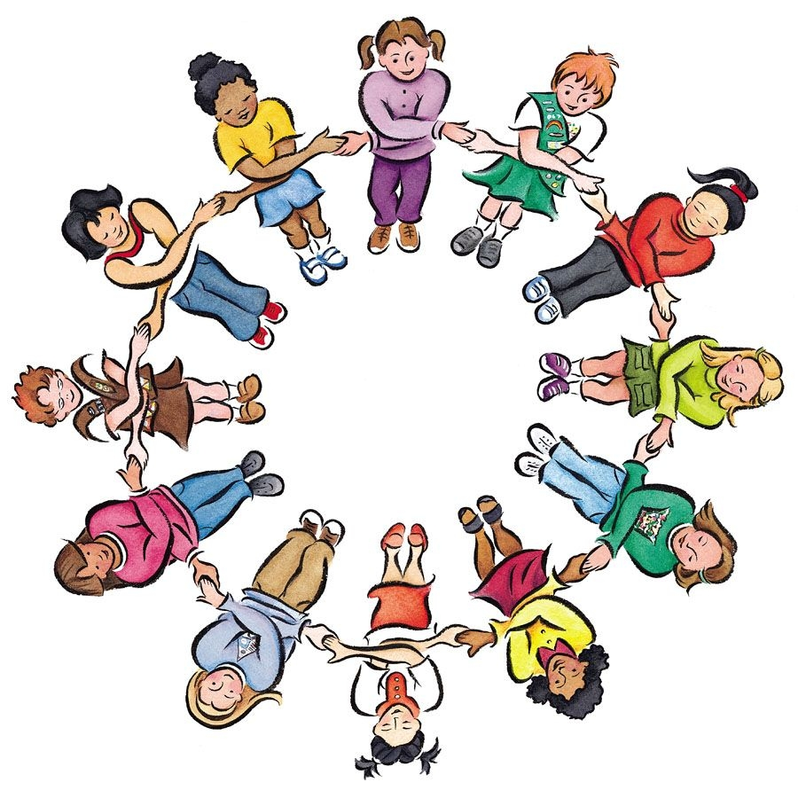](https://www.google.co.uk/url?sa=i&rct=j&q=&esrc=s&source=images&cd=&cad=rja&uact=8&ved=0ahUKEwjlxo24q9DRAhVGExoKHaJxDRAQjRwIBw&url=https://www.clipartsgram.com/primary-school-student-clipart-26983&psig=AFQjCNHyjw1mFTJ3dnv876NUAENEXHPJ0g&ust=1484988509729087)

We continue to thank parents for their partnership with our school and their involvement in their child’s learning. Please do not hesitate to speak to your child’s teacher if you have any questions or concerns.

[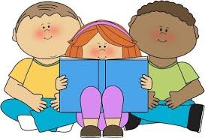](http://www.google.co.uk/url?sa=i&rct=j&q=&esrc=s&source=images&cd=&cad=rja&uact=8&ved=0ahUKEwiI9O7fsdDRAhVJBBoKHR_RDhgQjRwIBw&url=http://www.etruscan.stoke.sch.uk/parents-1/curriculum/phonics&psig=AFQjCNGJJax-vDtZSwyWKAR7nPDNNRdrEA&ust=1484990199655986)

# ‘Everyone valued, everyone challenged, everyone achieving’

 [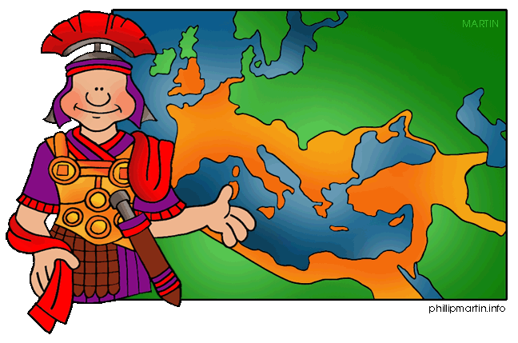](http://www.google.co.uk/url?sa=i&rct=j&q=&esrc=s&source=images&cd=&cad=rja&uact=8&ved=0ahUKEwitouz0vNDRAhUCvBQKHXcPBY0QjRwIBw&url=http://www.clipartpanda.com/categories/empire-clip-art&psig=AFQjCNG4ePMkDraGkZVPkOAuw75RfagT1Q&ust=1484993085339969)

[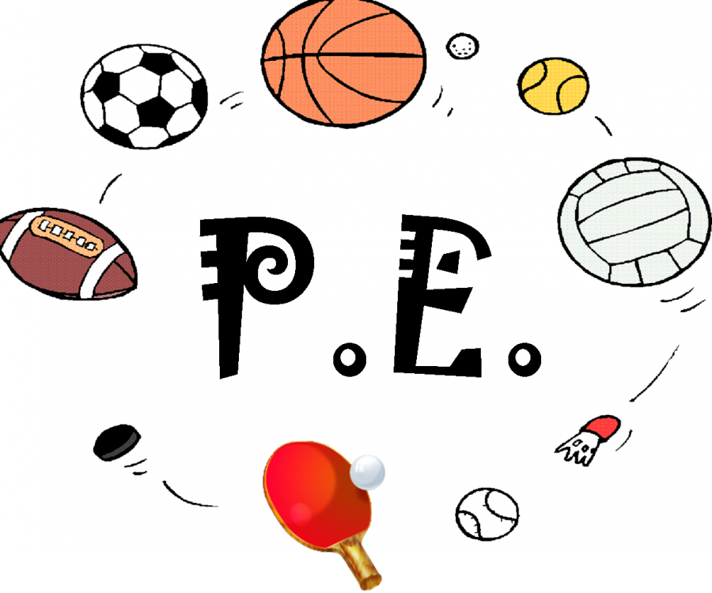](http://www.google.co.uk/url?sa=i&rct=j&q=&esrc=s&source=images&cd=&cad=rja&uact=8&ved=0ahUKEwjM9snpwdDRAhVIXRQKHWT4CTMQjRwIBw&url=http://www.clipartkid.com/pe-cliparts/&psig=AFQjCNGe1xXVLo8Qu-MKMK949snepd1K6A&ust=1484994381881043)

4K - Mondays/Tuesdays

4H - Mondays/Tuesdays

4D - Mondays/Wednesdays

4G - Tuesdays/Wednesdays

Please remember to make sure your child has their PE kit on a Monday and that they take it home to wash on a Friday.

**History**

[](http://www.google.co.uk/url?sa=i&rct=j&q=&esrc=s&source=images&cd=&cad=rja&uact=8&ved=0ahUKEwitouz0vNDRAhUCvBQKHXcPBY0QjRwIBw&url=http://www.clipartpanda.com/categories/empire-clip-art&psig=AFQjCNG4ePMkDraGkZVPkOAuw75RfagT1Q&ust=1484993085339969)

**History** - Our topic will be about the early Islamic civilisation, including a study of Baghdad. Children will:

* study a non-European society that is different to British society
* learn how art and design was crafted in this period
* understand the similarities and differences between the lives of people
* learn about artefacts from that period of history.

A very exciting topic that will link to English and Arts!

**Home Learning**

Homework is a continuation of school work and is a great opportunity for your child to practise the skills they have learnt.

**Reading** – For the children to progress in their reading, they need to read aloud daily. Please write a short comment in their reading log to communicate to us how they are reading at home.

**Spellings** - Weekly spellings should be practised at home daily using the Read, Write, Look, Cover, Check strategy.

**English** – Please check your child’s homework book. Homework will relate to the unit of work for that week. We expect the same high standard of writing produced in a lesson.

**Maths** - Activities are given based on the unit of work taught that week and is set on the Mathletics website.

Website: [www.mathletics.co.uk](http://www.mathletics.co.uk)

Children also need to learn their times tables off by heart at home up to 12x12.

**Speak Up!** - A poem will be given to be learned off by heart at the beginning of each half term. These will be performed in an assembly each half term.

[](http://www.google.co.uk/url?sa=i&rct=j&q=&esrc=s&source=images&cd=&cad=rja&uact=8&ved=0ahUKEwi0t6bvq9DRAhXFPRQKHWT9CIEQjRwIBw&url=http://www.clipartkid.com/holiday-homework-clipart-i1-stoneyhill-primary-school-JO8BUw-clipart/&psig=AFQjCNHyjw1mFTJ3dnv876NUAENEXHPJ0g&ust=1484988509729087)

**Educational Visits**

[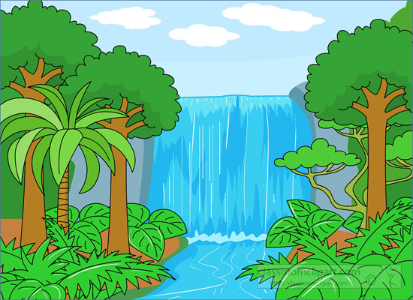](http://www.google.co.uk/url?sa=i&rct=j&q=&esrc=s&source=images&cd=&cad=rja&uact=8&ved=0ahUKEwjFsMa2udDRAhXEbxQKHbDaDa4QjRwIBw&url=http://www.turveylower.co.uk/page/?title%3DZebras%2BClass%26pid%3D9&psig=AFQjCNHT_7Xwk-DHaep30KVTycEdZeUp_Q&ust=1484990811197611)

In May, we will visit the V&A museum where children will get the opportunity to view a wide range of Islamic art and design, and listen to a talk about this area of history. We will also visit East London Mosque in July as part of our learning about local religions. These visits will really enrich the children’s learning around the topics we are studying.

**Art/DT/Music**

[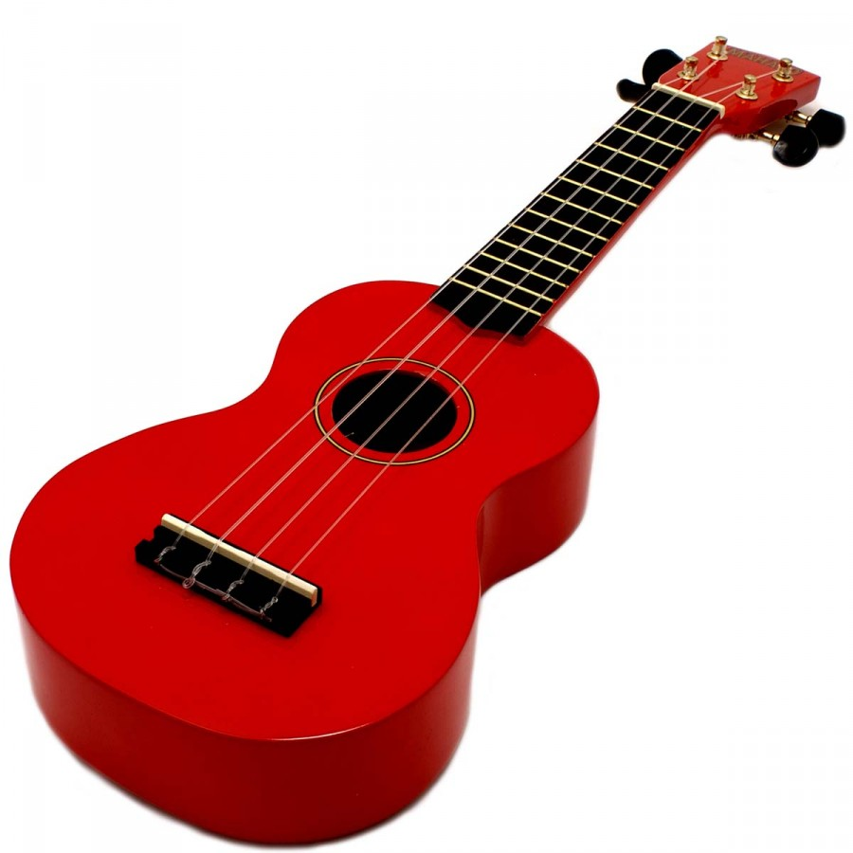](http://www.google.co.uk/url?sa=i&rct=j&q=&esrc=s&source=images&cd=&cad=rja&uact=8&ved=0ahUKEwjeu6OVv9DRAhVMuBoKHQC6D4wQjRwIBw&url=http://ovidiacom125.livejournal.com/&psig=AFQjCNHxYeIV9M1QHdlUbq-WwUZMgeYF3A&ust=1484993800087077)

**Art** – We are learning about art in religion and will do some observational 3D drawings using Islamic art’s geometry and patterns.

**Music** - Ukelele lessons will be provided on a weekly basis during our ECaM sessions.

**DT** - We will create alarms, linking with our ‘Electricity’ Science unit.

**R.E/PSHE**

[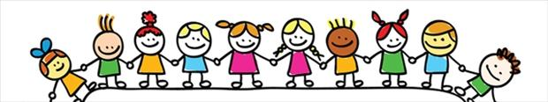](http://www.google.co.uk/url?sa=i&rct=j&q=&esrc=s&source=images&cd=&cad=rja&uact=8&ved=0ahUKEwimvrSrwtDRAhXGQBQKHak6BO0QjRwIBw&url=http://www.st-teresas-penwortham.lancs.sch.uk/learning/PSHE_citizenship&psig=AFQjCNHBdp-Ky8-cl4rpl7JLsh2YwvMg3g&ust=1484994639042250)

**R.E.** - We will be looking at what happens when Muslims/Sikhs get married. We will also learn about local religions with the focus on Islam.

**PSHE** – Our topics will be ‘Relationships’ and ‘Changes’, helping children understand themselves and others.

# ‘Everyone valued, everyone challenged, everyone achieving’