HH00236_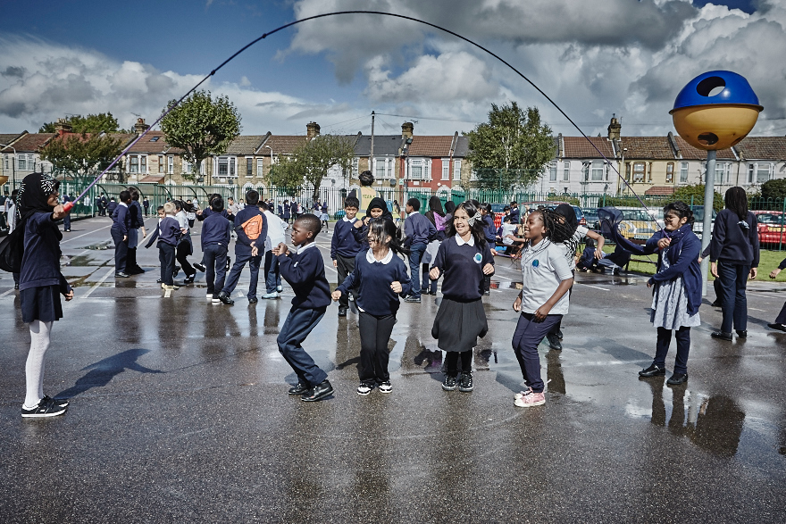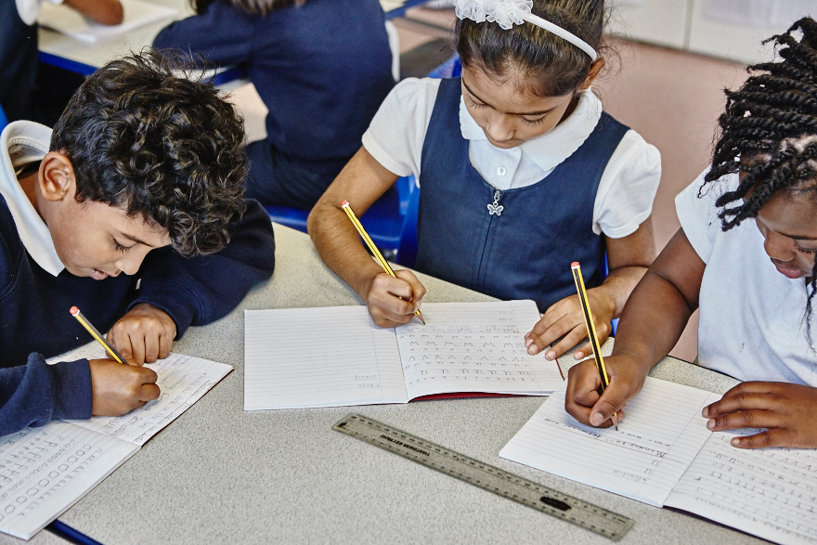

[](http://www.google.co.uk/url?sa=i&rct=j&q=&esrc=s&source=images&cd=&cad=rja&uact=8&ved=0ahUKEwiI9O7fsdDRAhVJBBoKHR_RDhgQjRwIBw&url=http://www.etruscan.stoke.sch.uk/parents-1/curriculum/phonics&psig=AFQjCNGJJax-vDtZSwyWKAR7nPDNNRdrEA&ust=1484990199655986)

**Science**

In science we will be revising in preparation for a test on the 16th June. Children need to be familiar with all topics covered during Key Stage 2 including:

* living things and their habitats
* animals including humans
* evolution and inheritance
* materials
* rocks
* sound
* light
* Earth and space
* forces
* electricity
* working scientifically.

**Mathematics**

In Mathematics, we will be revising the Year 6 curriculum in preparation for the Year 6 SATS test. Please ensure your child is completing their maths CGP homework every evening.

[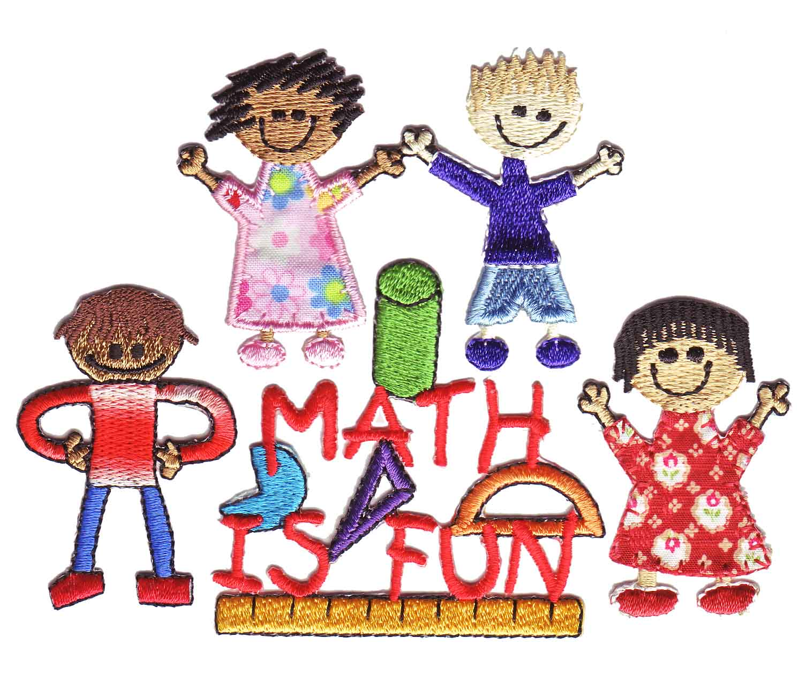](http://www.google.co.uk/url?sa=i&rct=j&q=&esrc=s&source=images&cd=&cad=rja&uact=8&ved=0ahUKEwjKtb78rNDRAhWDPRQKHZF-BdoQjRwIBw&url=http://www.clipartkid.com/clip-art-of-math-in-primary-school-students-cliparts/&psig=AFQjCNGsvAFr1O3-BrHlYzQEBOu73UpoAg&ust=1484988913636669)

.

[](http://www.google.co.uk/url?sa=i&rct=j&q=&esrc=s&source=images&cd=&cad=rja&uact=8&ved=0ahUKEwjKtb78rNDRAhWDPRQKHZF-BdoQjRwIBw&url=http://www.clipartkid.com/clip-art-of-math-in-primary-school-students-cliparts/&psig=AFQjCNGsvAFr1O3-BrHlYzQEBOu73UpoAg&ust=1484988913636669)

**English**

**Writing** – Our English units will mainly link with the following focus texts:

*Holes* by Louis Sachar

*Macbeth* by William Shakespeare

T*he Kites are Flying* by Michael Morpurgo

*The Sad Book* by Michael Rosen.

We will be writing letters, stories, recounts and reports.

**Reading** – During Guided Reading the children will focus on:

* Developing different reading strategies
* Improving their comprehension skills using Reciprocal Reading to deepen understanding.

They will be taught to:

* Provide evidence from the text
* Make sensible predictions
* Clarify meanings
* Summarise text.

**Speak Up!** - We are continuing to promote Standard English in both speaking and writing.

**Computing**

[](http://www.google.co.uk/url?sa=i&rct=j&q=&esrc=s&source=images&cd=&cad=rja&uact=8&ved=0ahUKEwjvz8_Qs9DRAhXIshQKHS9rD38QjRwIBw&url=http://nwamotherlode.com/archives/category/what-husbands-really-think&psig=AFQjCNF91pN4sLBQcLXpaLjA2c-1aSmpng&ust=1484990669800394)

|  |
| --- |
|  |

ICT skills will also be included within all subjects.

**Year 6 Curriculum Newsletter - Summer Term 2016/17**

Mr. Kelly (YGL) -6J

Ms. Musa – 6M

Ms. Smyth – 6S

Ms. Simmons – 6R

[](https://www.google.co.uk/url?sa=i&rct=j&q=&esrc=s&source=images&cd=&cad=rja&uact=8&ved=0ahUKEwjlxo24q9DRAhVGExoKHaJxDRAQjRwIBw&url=https://www.clipartsgram.com/primary-school-student-clipart-26983&psig=AFQjCNHyjw1mFTJ3dnv876NUAENEXHPJ0g&ust=1484988509729087)

We continue to thank parents for their partnership with our school and their involvement in their child’s learning. Please do not hesitate to speak to your child’s teacher if you have any questions or concerns.

# ‘Everyone valued, everyone challenged, everyone achieving’

 [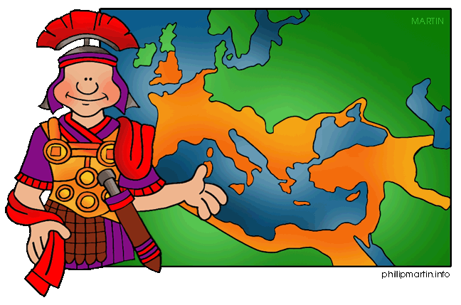](http://www.google.co.uk/url?sa=i&rct=j&q=&esrc=s&source=images&cd=&cad=rja&uact=8&ved=0ahUKEwitouz0vNDRAhUCvBQKHXcPBY0QjRwIBw&url=http://www.clipartpanda.com/categories/empire-clip-art&psig=AFQjCNG4ePMkDraGkZVPkOAuw75RfagT1Q&ust=1484993085339969)

**Art/D.T**

**Art** – Claude Monet

We will investigate light and colour and study Impressionism, with a focus on the water lily paintings by Claude Monet.

**R.E/PSHE**

[](http://www.google.co.uk/url?sa=i&rct=j&q=&esrc=s&source=images&cd=&cad=rja&uact=8&ved=0ahUKEwimvrSrwtDRAhXGQBQKHak6BO0QjRwIBw&url=http://www.st-teresas-penwortham.lancs.sch.uk/learning/PSHE_citizenship&psig=AFQjCNHBdp-Ky8-cl4rpl7JLsh2YwvMg3g&ust=1484994639042250)

**R.E.** – we will be looking at the qualities important for religious leaders and the similarities and differences between religions.

**PSHE** – Our topic will be ‘Changes’ and we will discuss how our lives might change going to secondary school.

**Educational Visits**

Plans are underway to reward the hardworking efforts of the children during the last week of the Summer 2 term with a visit to Southend-on-Sea’s ‘Adventure Island’ theme park. Date to be advised. Watch this space!

**SATS**

The key stage 2 tests are timetabled from Monday 8 May to Thursday 11 May 2017.

|  |  |
| --- | --- |
| **Date** | **Activity** |
| Monday 8 May 2017 | English reading |
| Tuesday 9 May 2017 | English grammar, punctuation and spelling Paper 1: questions  English grammar, punctuation and spelling Paper 2: spelling |
| Wednesday 10 May 2017 | Mathematics Paper 1: arithmetic Mathematics Paper 2: reasoning |
| Thursday 11 May 2017 | Mathematics Paper 3: reasoning |

[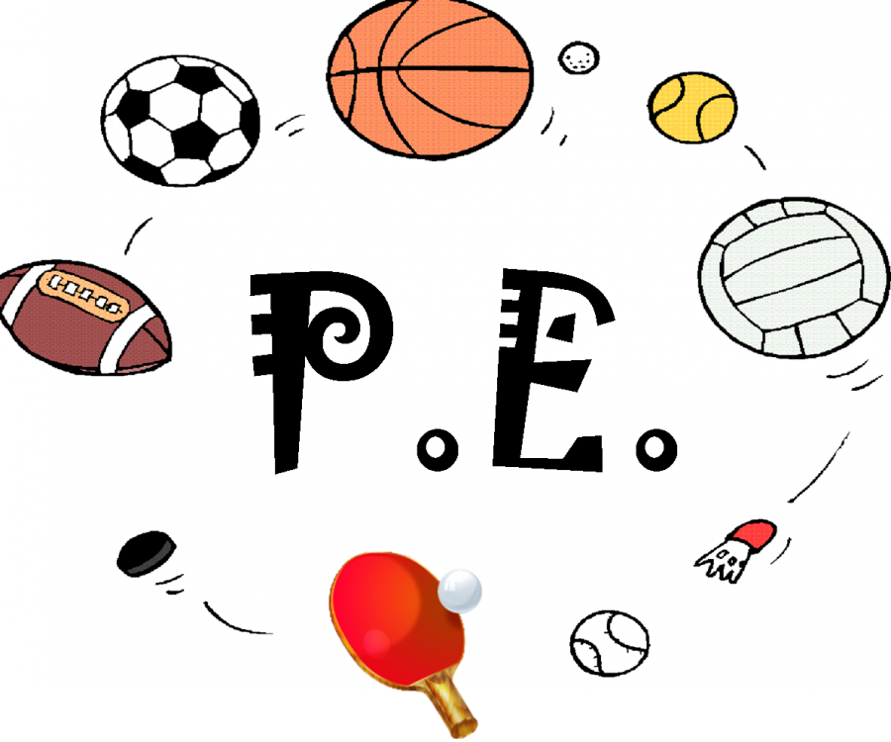](http://www.google.co.uk/url?sa=i&rct=j&q=&esrc=s&source=images&cd=&cad=rja&uact=8&ved=0ahUKEwjM9snpwdDRAhVIXRQKHWT4CTMQjRwIBw&url=http://www.clipartkid.com/pe-cliparts/&psig=AFQjCNGe1xXVLo8Qu-MKMK949snepd1K6A&ust=1484994381881043)

6J - Monday/Thursday

6R - Monday/Thursday

6M – Tuesday/Thursday

6S – Tuesday/Thursday

Please remember to make sure your child has their PE kit on a Monday. (They will take it home to wash on a Friday.)

**Home Learning**

Homework is a continuation of school work at home and is a great opportunity for your child to practice the skills they have learnt.

**Reading** – CGP homework plus daily reading of a book.

**Spellings** - Weekly spellings should be practised at home daily using the Read, Write, Look, Cover, Check strategy.

**English** – CGP punctuation homework.

**Maths** – CGP homework and mathletics.

[www.mathletics.co.uk](http://www.mathletics.co.uk)

**Speak Up!** - Children will be asked to discuss a topic with you in preparation for a writing task each week.

**Science** – CGP homework plus additional project work.

[](http://www.google.co.uk/url?sa=i&rct=j&q=&esrc=s&source=images&cd=&cad=rja&uact=8&ved=0ahUKEwi0t6bvq9DRAhXFPRQKHWT9CIEQjRwIBw&url=http://www.clipartkid.com/holiday-homework-clipart-i1-stoneyhill-primary-school-JO8BUw-clipart/&psig=AFQjCNHyjw1mFTJ3dnv876NUAENEXHPJ0g&ust=1484988509729087)

# ‘Everyone valued, everyone challenged, everyone achieving’